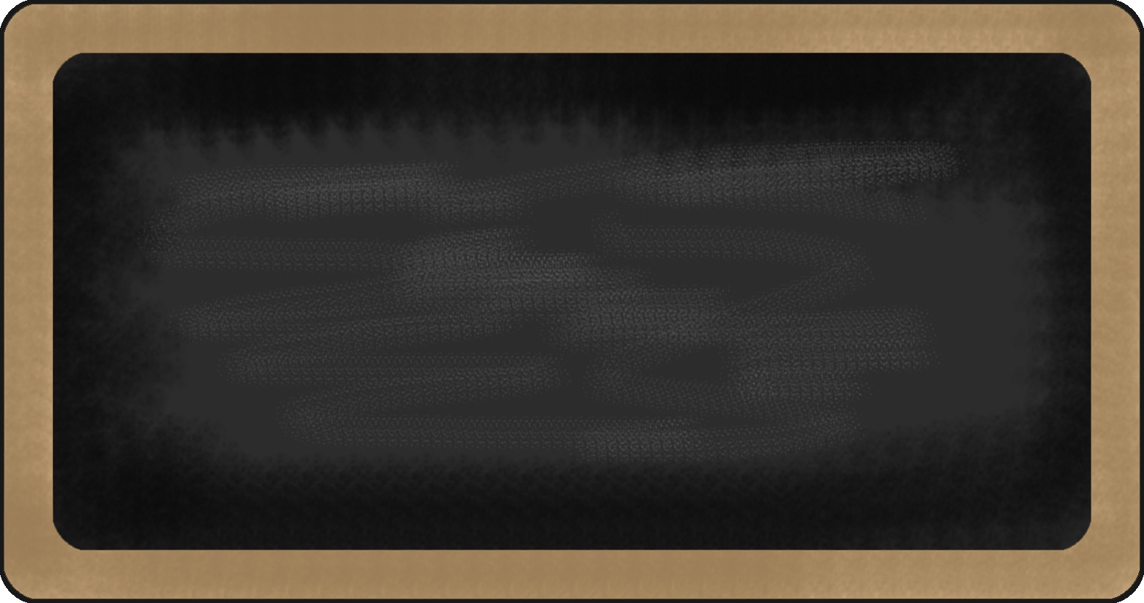
This week, the 5th Grade Crew Leader is Raneem. Way to go, Raneem. The Crew shines their halos for you!

Kronk’s Crew News 9/4-9/7

Upcoming events

9/10 week – NWEA Language Arts test/DRA TEST
9/17 week – NWEA Reading Test
9/24 week – NWEA Math Test
10/1 week – NWEA Science Test

Reading | Writing | Grammar | Math | Science | Social studies
- Fact v Opinion  - Comprehension strategies  - DRA Test | - Text Dependent Analysis  - Identifying story elements | - 4 Types of Sentences  - Vocab starts 9/7 | - Multiplication Facts must be mastered  - Powers of 10 | - States of Matter  - Scientific Method | - Navigating an Atlas, other references  - The Government overview  

Notes from the teacher:
Reminder that snacks in the classroom should be HEALTHY. No fried foods/chips, candy/chocolate. Only plain water bottles (that are plastic) are permitted in the classroom (no juice, flavored waters, or powdered drinks). Please save those types of snacks/drinks for lunchtime only.
Sign up for REMIND by texting @eak787 to 81010

Mohamed Soueidan’s birthday is 9/10; HAPPY BIRTHDAY!

What we are learning this week:

Any questions, comments, or concerns please reach out! hedked@dearbornschools.org,

