**Skill: Interpreting Graphs Name/Hour:__________________________________**

**Directions:** Use the graphics below to answer the following questions.

1. According to the graphic below, which of the following statements is true?

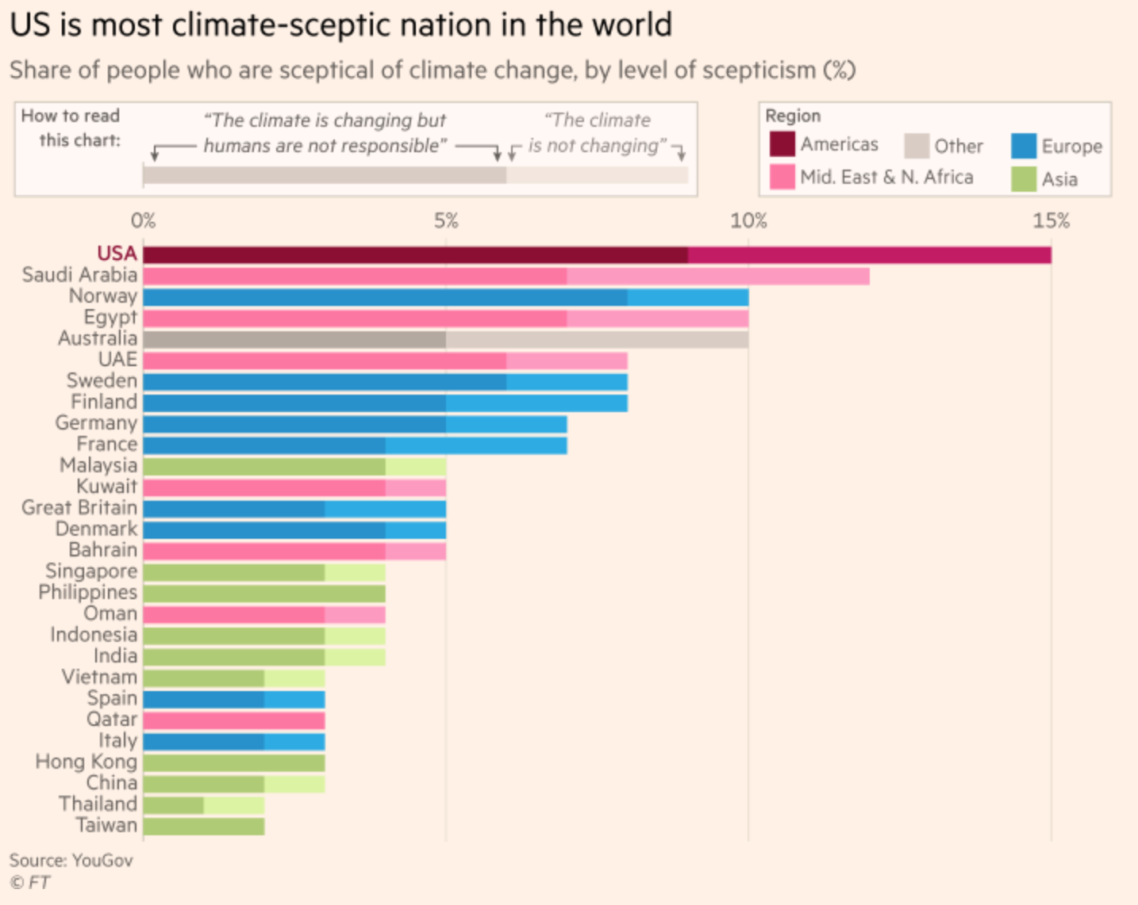

a. Asian countries are the most climate-skeptic.

b. The USA is not the most climate-skeptic.

c. Australia is a more climate-skeptic country than Malaysia.

d. France is a more climate-skeptic country than Saudi Arabia.

2. According to the graphic below, which of the following statements is false? 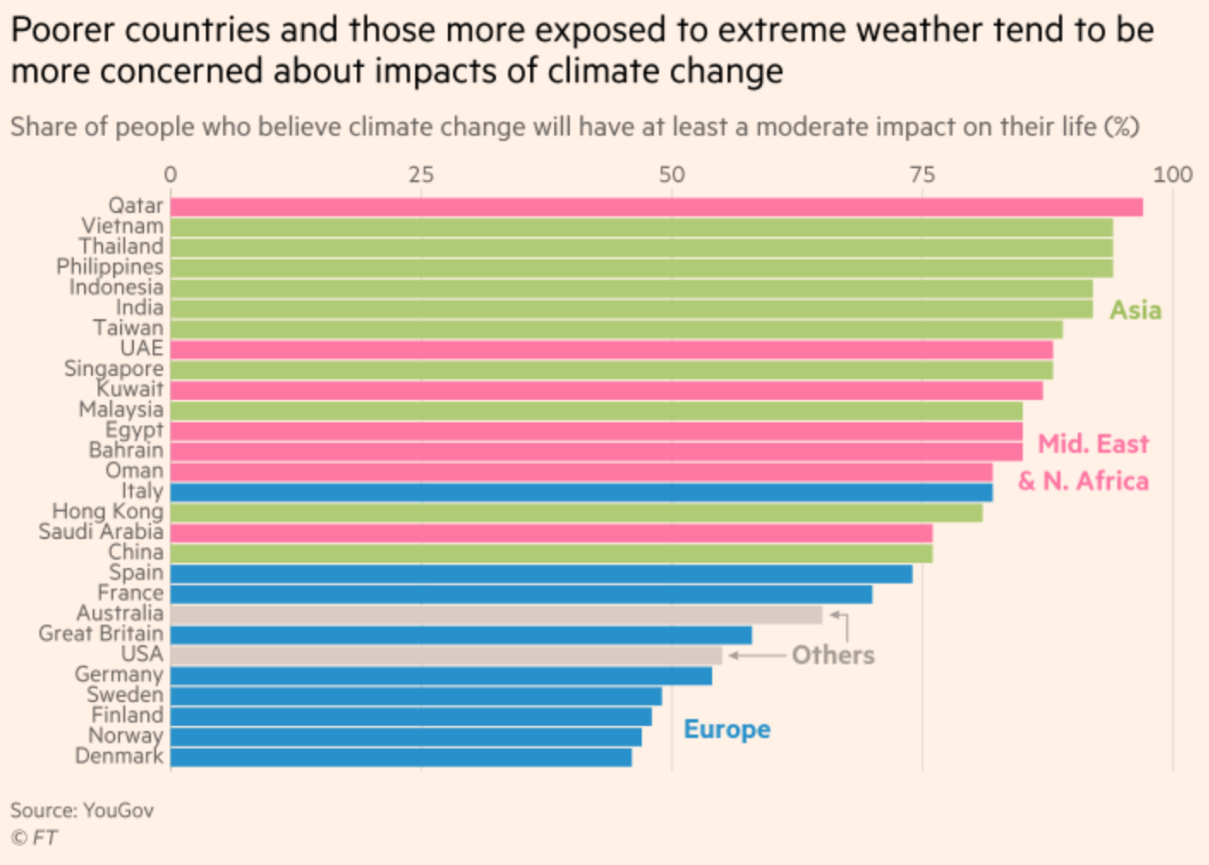

a. Europeans are typically more concerned about the effects of climate change.

b. China is more concerned about the effects of climate change than Spain.

c. The UK is more concerned about the effects of climate change that the USA.

d. Asia makes up the bulk of the most concerned countries.

3. Make Inferences: Why do you think poorer countries more concerned than wealthier countries about the effects of climate change?

Poorer countries are more concerned because________________________________________________________

_____________________________________________________________________________________________.