**A.O.W. #2                            Name:                                               Hour:**

1. Chunk the article into manageable (2 paragraphs max) pieces. **Number them.** Don’t forget the title/opening!

2**. Highlight** at least three unfamiliar/essential words and **define them** on the graphic organizer.

3. Show evidence of a **close reading**. Mark up the left side of the text (each chunk) with questions and/or comments that demonstrate interacting with the text. You may also include any confusion you have.

4. Complete the attached graphic organizer to analyze author’s craft.

**‘How Dare You!’ Greta Thunberg Rebukes World Leaders**

By Mark Hertsgaard on SEPTEMBER 23, 2019

Sixteen-year-old Swedish climate activist Greta Thunberg speaks at the 2019 United Nations Climate Action Summit. *(Reuters Pictures / Carlo Allegri)*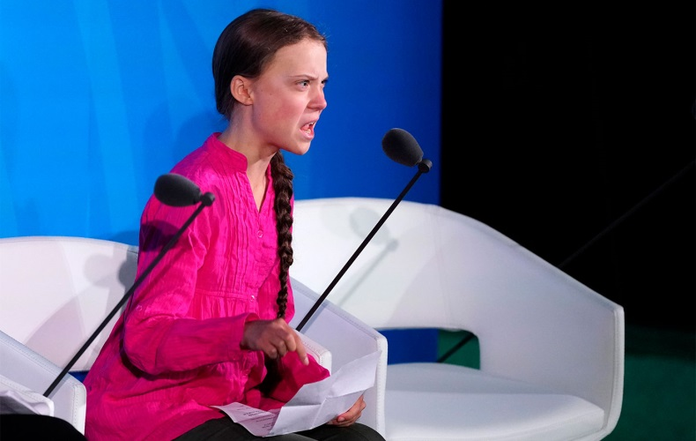

“We will not let you get away with this,” the 16-year-old climate strike leader tells the UN Climate Action Summit.

After rallying 4 million people into the streets on Friday in the biggest global climate strike yet, Swedish teenager Greta Thunberg brought her message inside United Nations Headquarters today with a furious speech that repeatedly demanded of world leaders, “How dare you?”

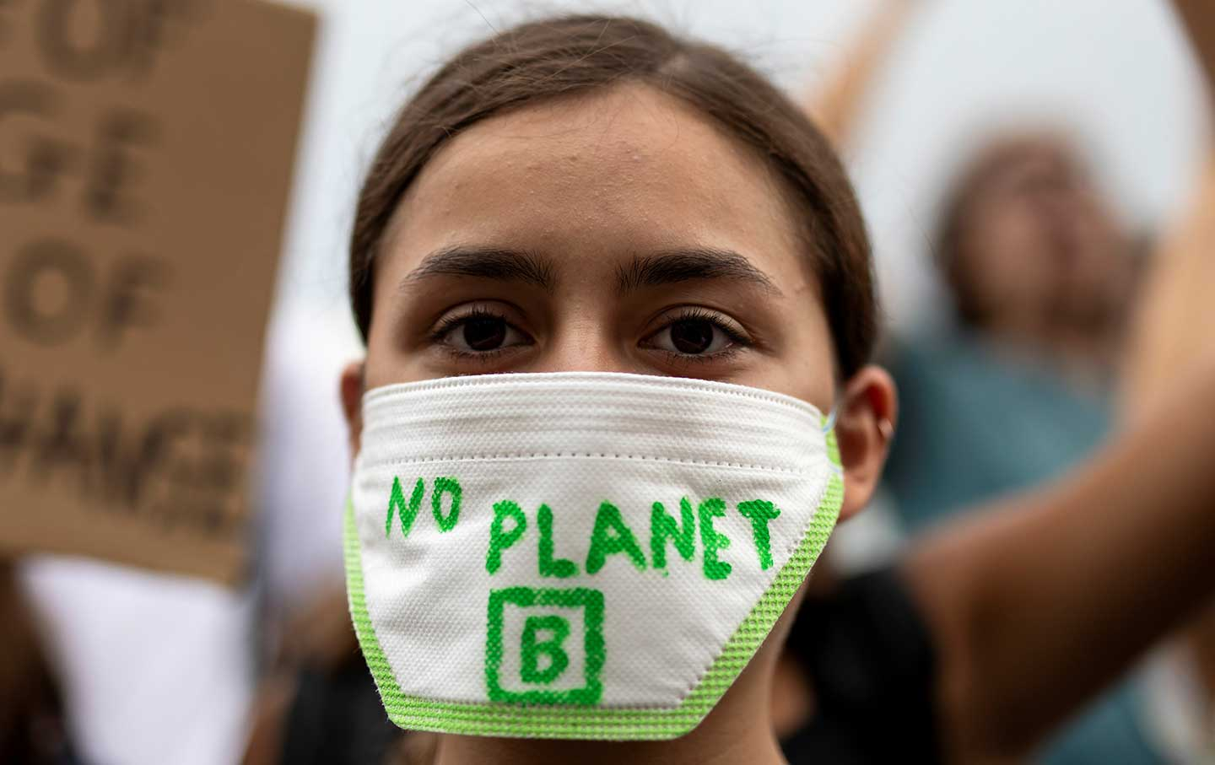

Seated alongside UN Secretary General Antonio Guterres and two other young climate activists, Thunberg opened the UN Climate Action Summit by blasting the assembled heads of government with a speech that was equal parts “J’accuse” and hardball politics.

“My message [to world leaders] is that we’ll be watching you,” Thunberg began. Then, as tears of rage and grief overtook her, the founder of the global climate strike movement all but shouted, “I shouldn’t be here. I should be back home, at school…. You come to us young people for hope. How dare you! You have stolen my childhood and my dreams. And I am one of the lucky ones. People all over the world are suffering and dying. And all you can talk about is money and fairy tales of eternal economic growth. How dare you!”

“For more than 30 years, the science has been crystal clear,” Thunberg continued. “How dare you look away and say that you are doing enough!” Noting that the world’s carbon budget for a 1.5 degree Celsius *(how much warmer the planet can get before there’s irreparable harm)*  future will be exhausted within 8.5 years if current trends continue, according to the scientists of the UN Intergovernmental Panel on Climate Change, she repeated, “How dare you pretend that this can be solved with business as usual?”

Predicting that none of the speeches from world leaders today would wrestle with those imposing numbers, Thunberg declared that world leaders are “still not mature enough to tell it like it is.” The fury returning to her face, she warned, “You are betraying us…. If you choose to fail us, then I say, ‘We will never forgive you.’”

As Thunberg’s speech appeared live on one internal UN video feed, a second feed showed Donald Trump arriving at the UN—but not for the Climate Action Summit. In a clear snub, the White House instead reserved a conference room where Trump would attend a conference on religious freedom along with Secretary of State Michael Pompeo. Michael Bloomberg, the former New York City mayor who now serves as a United Nations special envoy on climate action, called out the US president by name in a separate speech to the Climate Action Summit, declaring in a perfect deadpan that he thanked Trump for coming to the UN today and hoped that suggestions made at the summit “will be helpful as he formulates a climate policy” for the US.

Greta Thunberg, for her part, made it clear that she and other young activists will take no prisoners as they demand emergency action against climate breakdown. In a challenge to Trump and all leaders who are not stepping up at this decisive moment in human history, Thunberg warned, her eyes flashing, “We will not let you get away with this. Right here, right now, is where we draw the line. The world is waking up. And change is coming, whether you like it or not.”

1. Author’s claim (what he/she wants us to believe, **OPINION + REASON**):

2**. Text Evidence** for claim with **MLA:** *TE= proof: stats, facts, examples **MLA= author’s last name in parenthesis at the end of each piece of TE: “Blah-blah-blah” **(Author’s LAST name)**.



3. The author’s purpose is to ______________________________________________ **(persuade, argue, give opinion)** and he/she achieves the purpose through the following **techniques (*include technique name and example/evidence)***:

1. Technique/Example:
2. Technique/Example:
3. Technique/Example:

4. The author’s main audience is **(Be specific)** ___________________________________________________________

because_________________________________________________________________________________________.

5. The author establishes a __________________________________________ **tone** (look at word choice) through the following QUOTED **words/phrases:**



6. **Three words** I didn’t know (or ESSENTIAL words) WITH **DEFINITIONS**