# 

**A.O.W. #4: Due by Thursday this week! Name: Hr.**

1. Chunk the article into manageable (2 paragraphs max.) pieces. **Number them. Don’t forget the title/opening!**
2. Highlight at least three words you are not familiar with or that are important and define them on the graphic organizer.
3. Show evidence of a close reading. Mark up the **left side** of the text (**each chunk)** with questions and/or comments that demonstrate interacting with the text. You may also include any confusion you have.
4. Complete the attached graphic organizer to analyze author’s craft

# **Lee's estate fights Broadway play based on "To Kill a Mockingbird"**

By The Guardian, adapted by Newsela staff01/02/2019

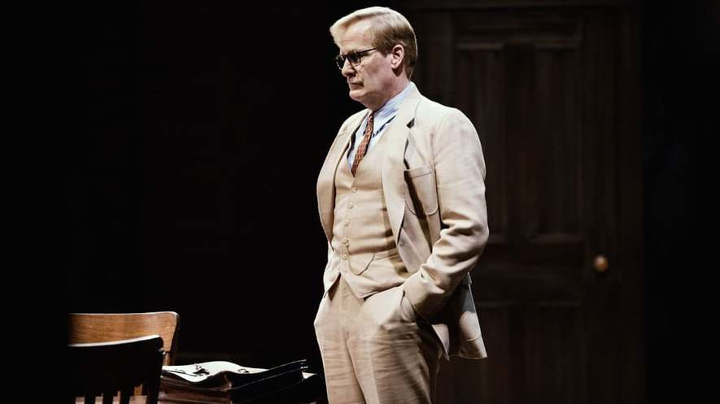

Jeff Daniels as Atticus Finch in the Broadway production of "To Kill a Mockingbird." Photo by: Julieta Cervantes/The Guardian

When someone dies, their personal assets, such as their money, cars and jewels, are known as their estate. That estate is usually controlled by a lawyer or family member. But things can get complicated with artists' estates, which include their creative works. The estate of Harper Lee, the author of the famous novel "To Kill a Mockingbird," recently was involved in a lawsuit concerning the Broadway adaptation of her acclaimed novel. The result was that the producers of the play, which opened in December, were forced to make some changes. Specifically, they needed to **change** their portrayal of Lee's iconic lawyer and protagonist, Atticus Finch, who they wrote as a man who drinks alcohol, keeps a gun and curses mildly.

Instead, the character played by actor Jeff Daniels is "as the estate wanted … a clean-living hero throughout, who is described in the play's opening moments as the 'most honest and decent person in Maycomb,'" according to the New York Times, which has seen previews of the much-anticipated production. Maycomb is the fictional Alabama town where "To Kill a Mockingbird" takes place.

## **Objections To Main Character's Portrayal**

In March, a lawsuit from the late author's estate had claimed that the script, which was written by Aaron Sorkin, departed from the spirit of the novel. The lawsuit was particularly concerned with the portrayal of Atticus. Tonja Carter, Lee's former lawyer, filed the suit. She said that "for this classic, it is really important that any spin put on the characters, not least Atticus, does not contradict the author's image of them." The image of Atticus, the small-town lawyer who defends a black man wrongly accused of rape, Carter added, "is portrayed in the novel as a model of wisdom, integrity and professionalism."

Producer Scott Rudin's office released documents at the time of the suit, including a letter in which Carter complained that Sorkin's Atticus "is more like an edgy sitcom dad in the 21st century than the iconic Atticus of the novel." Rudin's company Rudinplay later countersued, by filing a lawsuit against Carter and the estate. Both parties settled amicably, or on good terms, in May, allowing the play to proceed.

The New York Times reported that previews of the play revealed "dramatic changes" to the novel, specifically around the work's black characters. Sorkin's play centers on the trial of Tom Robinson, the black man accused of raping a white woman who is defended by Finch. Robinson and the Finch family's housekeeper Calpurnia, also black, "express anger and frustration" **beyond anything** seen in the novel. In one scene, Robinson tells Finch, "I was guilty as soon as I was accused."

## **Highly Charged Political Issues Avoided**

The Times report added that Carter had objected to "about 80" elements in the script, with "about 40 percent of those elements now gone." According to the paper, a new character — a black doctor who would have testified at the rape trial — was dropped from the play. The estate had said that he "introduces numerous highly charged political issues into the trial."

Sorkin, the screenwriter of the movies "The Social Network" and "Steve Jobs," wrote in New York Magazine that he had been asked by Rudin "what items on Carter's list of objections I was willing to alter to her satisfaction." None, he replied. "The play can't be written by a team of lawyers."

But with the play in jeopardy if the dispute wasn't settled, Sorkin made some concessions. He wrote of the interaction, that he "finally said, 'If Tom Robinson and Calpurnia are taken off the table as issues, I'll cut the swear words, Atticus won't have a rifle in his closet and he won't drink a glass of whiskey after the trial.'"

## **Using Black Characters Only As Atmosphere Is Wrong**

Sorkin wrote that he felt that **Lee's novel** had not shown Calpurnia's or Robinson's reactions to the racial injustice around them: "Tom begs for his life, and Cal bakes crackling bread. It's the kind of thing that would have gone unnoticed in 1960, the time of the novel’s publication, but in 2018, using black characters only as atmosphere is as noticeable as it is wrong. Also, in this instance, a wasted opportunity."

Sorkin alleged that Carter had objected to the following exchange between Calpurnia, the Finch family maid, and Atticus:

Calpurnia: Jem was stickin' up for you and maybe a little bit me and you made him say he was sorry.

Atticus: I believe in being respectful.

Calpurnia: No matter who you're disrespecting by doin' it.

Sorkin said that Carter had responded to this interaction with, "A typical black maid in the South at this time would never talk to their employer this way."

Sorkin wrote, "A coupla thoughts: There's no such thing as a typical black maid. Plays aren't written about typical people doing typical things."

According to the New York Times, the play's producers prevailed, and Sorkin's script gives Calpurnia and Robinson a greater voice. Carter declined to be interviewed by the paper, while Rudin said that the production is "exactly the play we want to present … A small handful of issues were simply not important to us, and out of deference to the estate's wishes, we agreed to them."

1. **Author’s claim** (what he/she wants us to believe, **OPINION + REASON**):

2**. Text Evidence** for claim with **MLA:** **TE= proof: stats, facts, examples **MLA= author’s last name in parenthesis at the end of each piece of TE: “Blah-blah-blah” **(Author’s LAST name)**.



3. The author’s purpose is to _________________________ **(persuade, give opinion)** and he/she achieves the purpose through the following  **techniques/ examples: *(FOR EXAMPLE - Statistics: 99.9% of high schoolers do not read directions)***

1. Technique & example:
2. Technique & example:
3. Technique & example :

4. The author’s main audience is_____________________________________**(Be specific)**

***because***_______________________________________________________________________.

5. The author establishes a _____________________ **tone** (look at word choice) through the following **QUOTED words/phrases**



6. **Three words** I didn’t know (or ESSENTIAL words) WITH **DEFINITIONS**



7. **Occasion:** The event that prompted this text is _________________________ (be specific) because

__________________________________________________________________________.