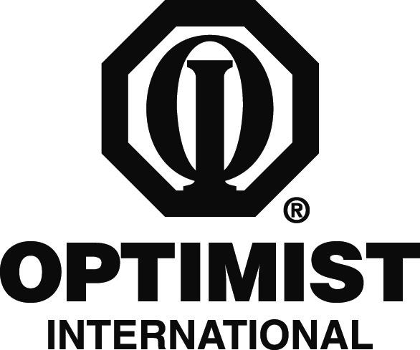

DEARBORN OPTIMIST CLUB

CONTACT
Lori Divis
313-204-6623

FOR IMMEDIATE RELEASE
November 1, 2011

Local Optimist Club to Sponsor Essay Contest for Students

Dearborn, MI – The Optimist Club of Dearborn is encouraging area students to contemplate the phrase “How My Education is the Key to a Successful Future” as part of the Optimist International Essay Contest for 2011.

The Optimist Club will judge the local students’ essays, based on the theme of “How My Education is the Key to a Successful Future” and determine the top winners. Winners will receive scholarship awards and the winning essays will be sent to the district level. Essays will be judged at the district level, and each district will send top entries to the international level. College scholarships are available for top winners at the district level. District winners are entered into the international-level judging, and one first-place winner will be awarded an engraved plaque and recognition in The Optimist magazine.

“Young students today have so many fresh ideas about the world and their future,” Club President R. J. Dubitsky said. “As Optimists, it is our goal to encourage them and do what we can to bring out the best in each of them. This gives them a wonderful opportunity to tap into their creativity and pursue possible scholarships at the same time.”

The Optimist Club of Dearborn has been participating in the Optimist Essay Contest for 53 years and has been active in the community since 1940. Other programs and service projects that the Club is involved in include oratorical and art contests.

Students wishing to participate in the essay contest can find out more about the contest by contacting the club at 313-204-6623.

Optimist International is one of the world’s largest service club organizations with 100,000 adult and youth members in 3,400 clubs in the United States, Canada, the Caribbean and Mexico and throughout the world. Carrying the motto “Bringing Out the Best in Kids,” Optimists conduct positive service projects that reach more than six million young people each year. To learn more about Optimist International, please call (314) 371-6000 or visit the organization’s website at www.optimist.org.

###

