**Who remembers where this pic. is from?**

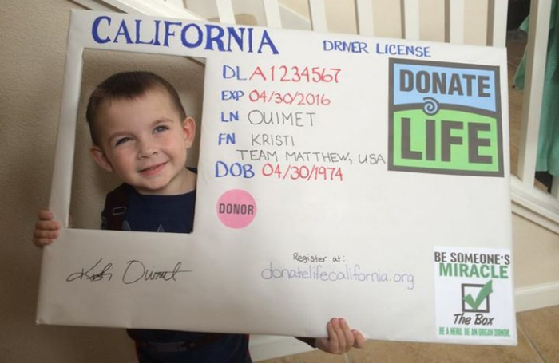

**We’re going to use AOW 6 to review GOLDEN LINE and COUNTER-**

**ARGUMENT so you’re ready for today’s TEXT SET. ☺**

**Bell Work #37, 12/14/18: GOLDEN LINE PRACTICE: Here are the three most popular pieces of evidence from AOW 6. *Write THE* *ONE* YOU THINK is the BEST. Add sound reasoning.**

**1. "If we are going to treat children as if they are merely made of harvestable parts, then we should also establish legal standards that provide an independent advocate (supporter) for the savior sibling" (Dickey).**

**2. "However, bringing children into the world because they have an ideal genetic makeup promotes the idea that children are merely commodities, their existence contingent (dependent) on their ability to save the life of a sibling" (Dickey).**

**3. "This leaves savior siblings who don't want to provide a live organ donation helpless, as they cannot control their medical decisions" (Dickey).**

**REASONING: Option #__ is the GOLDEN LINE because___________________________.**

**CLAIM: "If we are going to treat children as if they are merely made of harvestable parts, then we should also establish legal standards that provide an independent advocate for the savior sibling" (Dickey).**

**SO… let’s think like the disagreeers…**

**COUNTER CLAIM PRACTICE (the hard part)**

**Define counter-claim. Define rebuttal.**

**Okay, so let’s pretend you need a new kidney and your parents have a baby brother who is a match. What is the risk to YOU as the recipient if your parents have to hire a lawyer and go through legal channels for YOUR kidney transplant?**

**So, turn your COUNTER CLAIM sheet over and try to write a counter claim and rebuttal with your partner. It won’t be perfect.**

**Okay, so let’s pretend you need a new kidney and your parents have a baby brother who is a match. What is the risk to you as the recipient if your parents have to hire a lawyer and go through legal channels for YOUR kidney transplant?**

**Counter-claim phraseology…**

**SOME SAY____________________________**

**_______________________________________**

**THEY SAY THAT _______________________**

**_______________________________________**

**Rebuttal phraseology…**

**ALTHOUGH THESE ARE GOOD POINTS, (WHY IS YOUR SIDE BETTER?)**

**Now that you have Golden Line and Counter Argument, we’re ready to begin our text set today. We’ll finish over the next couple of days.**