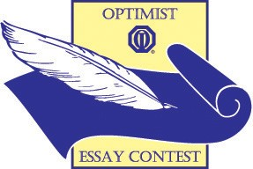
DEARBORN OPTIMIST CLUB

ESSAY CONTEST

“When All the World’s Problems
are Solved, is Optimism Still Necessary?”

Deadline: Monday, January 7, 2019

1st Prize: $500.00
2nd Prize: $250.00
3rd Prize: $125.00

Go to dearbornoptimist.org for official application and rules
Contact Person: Mrs. Lori Divis
E-mail: divislori@gmail.com
To submit essays via US mail: DEARBORN OPTIMIST CLUB
4801 Oakman Blvd., Dearborn MI 48126

