**A.O.W. 1 Name: Hour:**

1. Chunk the article into manageable (2 paragraphs max.) pieces. Number them. Don’t forget the title/opening!
2. Highlight at least three words you are not familiar with or that are important and define them on the graphic organizer.
3. **Show evidence of a close reading. Mark up the left side of the text (each chunk) with questions and/or comments that demonstrate interacting with the text. You may also include any confusion you have.**
4. **Complete the attached graphic organizer to analyze author’s craft.**

**\*\*Students, This week’s AOW is one side of the argument. Next week you’ll be reading about the other side.**

**Colin Kaepernick's new "Just Do It" Nike ad pressures NFL to take a stand**

**By Nancy Armour, USA Today; 09/07/2018**

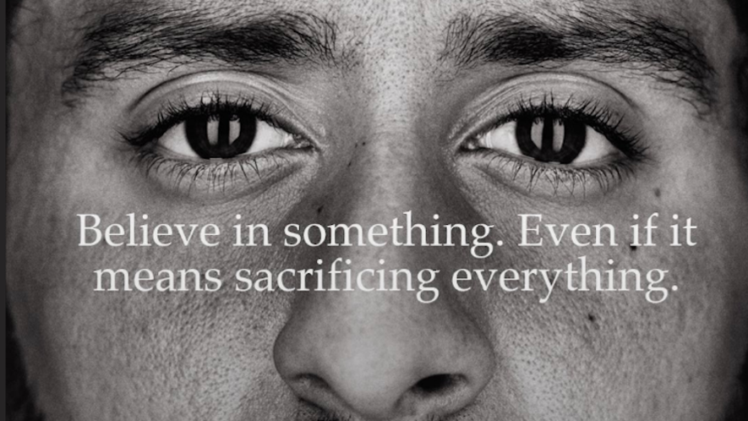

Colin Kaepernick is featured in Nike's 'Just Do It' 30th anniversary ad. Photo by: Colin Kaepernick/Twitter

Decades from now, when Americans look back at the NFL player protests and wonder how anyone could have seen them for anything but the plea for equality they are, Colin Kaepernick's new Nike ad will be one of the enduring images.

For two years now, the NFL and its owners have desperately tried to silence Kaepernick and the movement he began. They blackballed the former San Francisco 49ers quarterback and teammate Eric Reid. They threatened to fine or cut the players who joined them in protest. They created a ridiculous **policy** that only served to confuse matters more.

**And for what? To go down** on the wrong side of history? Because that's how future generations will see it, as the Nike ad released Monday made clear.

"Believe in something," the tagline reads. "Even if it means sacrificing everything."

This is not some small, left-leaning company that has decided Kaepernick is on the side of angels in this fight. It is one of the world's largest conglomerates, a setter of trends and arbiter of what's cool.

And it is one of the NFL's biggest partners, the official apparel company of the league.

For Nike to choose Kaepernick sends a message even Dallas Cowboys owner Jerry Jones cannot ignore. This is bigger than a hot-button issue in an election season, bigger than a **segment** of fans who choose to be angrier at the method of protest than the message behind it.

This is about America, and whether we actually honor the ideals we champion or simply pay lip service to those notions of liberty and justice for all.

While the NFL and its owners have been trying to contain the issue, Kaepernick and the other players have been playing the long game. The civil rights protests were wildly unpopular when they were occurring — go back and research the polls and opinions of the time — but are now viewed as righteous and essential to our ongoing struggle for equality. The NFL protests will be viewed much the same way through the lens of history.

Nike has recognized as much, betting a very large and prominent endorsement deal that Kaepernick will one day be seen much like Muhammad Ali. A rabble **rouser** who outraged the establishment in his heyday, Ali eventually became a widely admired and influential figure once society caught up.

Cynics will say this is simply a marketing ploy for Nike, a way to **capitalize** on an issue everyone is already talking about. Perhaps. But that doesn't lessen the burden on the NFL.

Or the stakes.

The league can continue to dither, trying to appease everyone while pleasing no one, and be remembered as an organization that put expedience ahead of equality. Or it can be bold.

By signing Kaepernick — and I mean a team giving him a **legitimate** chance to compete, not hiding him on the depth chart as a No. 3 quarterback — the NFL can tell the entire country that fighting for a truly equal society is a fight worth having. That while it recognizes the passions the player protests have produced, there is nothing dishonorable about holding our country to account.

There will be some backlash, sure. Just as some folks angered by Nike's stance will no doubt express their outrage with their wallets, refusing to buy shoes, shirts or anything else with a swoosh on it.

So be it.

Doing the right thing isn't always easy, especially in the moment. But this moment, and who stood for what during it, will be remembered for generations to come.

It's time to take a stand, NFL. Go ahead and do it.

1. Author’s claim (what he/she wants us to believe—OPINION + REASON)):
2. . Text Evidence for claim *with MLA*: **TE= proof: stats, facts, examples

**MLA= author’s last name in parenthesis at the end of each piece of TE: “Blah-blah-blah” (Author’s LAST name).

1. ________________________________________________________________________

________________________________________________________________________

1. ________________________________________________________________________

________________________________________________________________________

________________________________________________________________________

1. ________________________________________________________________________

_________________________________________________________________

1. _________________________________________________________________

_________________________________________________________________

(inform, persuade, give opinion, etc.)

1. The author’s main purpose is _________________because_________________________

_______________________________________________________________________________

**(Be specific)**

1. **The author’s main audience is __________________________because______________**

__________________________________________________________________________

1. The author establishes a _____________ tone (look at word choice) through the following techniques (refer to technique list, but make it **specific**) a._____________________

_______________,b. ____________________________, and c.______________________.

1. 3 words I didn’t know (or are ESSENTIAL words) WITH DEFINITIONS

a.

b.

**c.**