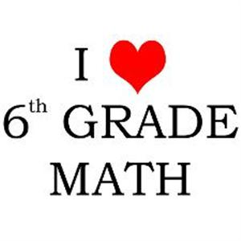**Sixth Grade Math Class Information**

Mrs.Klemetson and Ms. Peltz

2015-2016

Welcome to Stout Middle School. We are looking forward to a fantastic year together! With your cooperation this year will be filled with learning and fun!

**Contact us:** [**klemetl@dearbornschools.org**](mailto:klemetl@dearbornschools.org) **or** [**peltzk@dearbornschools.org**](mailto:peltzk@dearbornschools.org)

_____________________________________________________________

**We expect that you will…**

* treat everyone and everything in the classroom with respect.
* be in your seat every day when the bell rings ready to work.
* come to class every day prepared with everything you will need.
* wait until dismissal to pack up and leave the classroom.

Please make sure that you keep these expectations in mind every day.

_____________________________________________________________

**What you will need for class**

* **Interactive Student Notebook**-a composition book with the black/white cover. We have already purchased this for you.
* 1” **3 ring binder** with 5 divider tabs.
* **PENCILS!!** No pens, please!
* Other materials, like markers and pencils, might be needed throughout the year should be kept in your locker.
* We could use tape donations! Any type of clear tape would be appreciated!
* 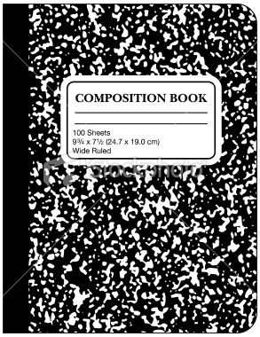Please let me know if you have trouble getting any of the needed supplies.

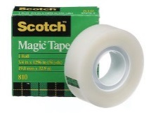

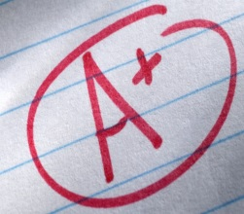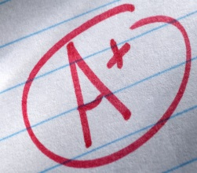­­­­­­­­­­­­­­­­­­­­­­­­­­­­­­­­­­­­

**Grading Policy**

Grades are earned in two categories-Formative grades and Summative Grades

* **Formative grades** can be earned by completing homework, weekly warm ups, keeping your ISN up to date, exit questions, group work.
* **Summative Grades** are earned through tests, quizzes, class activities, and other assignments throughout the year.
* **Your ISN will be graded each marking period!** Please keep it up to date.

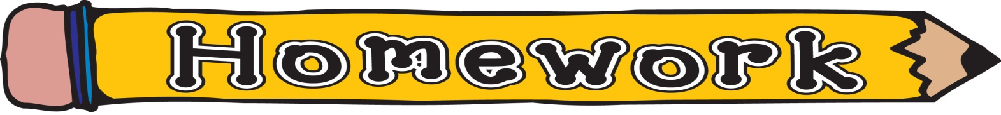

Homework will be assigned 2-3 times per week. Some homework will be posted on Google Classroom at the beginning of the week. Check our blog for more on this. Homework is due on the day it was assigned. It will still be accepted if late, but not for full credit.

**Lockers/Bathrooms**

* Students will be allowed passes each marking period to go back to their locker or use the restroom. Any passes not used can be applied as extra credit to the formative category of their grade, 2 points per pass.



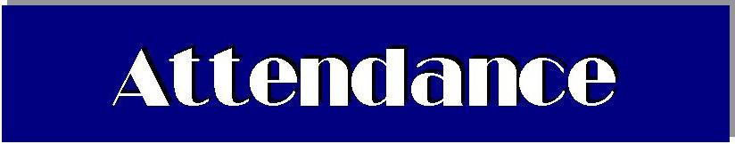

**Absent or Late?** If you are absent or late to class, it is your responsibility to get your missing notes for your ISN, get any homework you may have missed, and turn in any work you did not turn in when you were out.

**WATER AND SNACKS…are allowed as long as they are healthy choices. Students in 6/7 block are especially encouraged to bring a snack because lunch is early in the day. Please—water only!**