**Monitoring Volcanic Activity - Student Guide**

**Lesson Discovery Question:**

* How do scientists use data to predict volcanic eruptions?



To think about how scientists might figure out what's going on underneath a volcano, let's start with how you might figure out what's going on inside a cupcake.

1. **What could you guess about what is inside a cupcake by just looking at it?**

|  |
| --- |
|  |

1. **How would your guess about what is inside the cupcake change if you made additional observations:**
   * **smell the odors (scent) released by the cupcake?**
   * **use a toothpick to poke through the surface?**
   * **taste a piece of icing?**

|  |
| --- |
|  |

1. **What new information do you get from using more than one observation method?**

|  |
| --- |
|  |

The United States Geological Survey monitors all of the potentially dangerous volcanoes in the U.S. The scientists use a variety of tools to examine different types of signals that might indicate a volcano is about to erupt.

**Read about an important type of monitoring data: ”Volcanic Gas”**

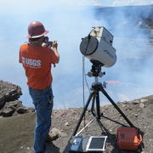

Deep beneath the surface of a volcano, gases are dissolved in the melted material (called **magma**), but as magma rises toward the surface the pressure decreases and **gases** separate from the liquid -- just like the hissing you hear when you open a can of soda!

An increase in gas output can be one of the first signs of increased volcanic activity. There is often a peak in the amount of gas released in the days before and during a volcanic eruption.

The types and amounts of escaping gases are tracked over time. Volcanic gases are measured both when volcanoes are erupting and when they are quiet.

Describe the main idea of the article **Volcanic Gas.**

|  |
| --- |
|  |

**In the figure below,  the solid red line shows the amount of gas escaping from an individual volcano over time. The solid triangles show when volcanic eruptions occurred. Scientists can compare changes in the amount of gas escaping from a volcano to the times when volcanoes erupt for clues about what is going on inside a volcano.**

1. **Identify and describe any pattern(s) you see in the graph of “Gas Emissions vs Volcanic Eruptions”. For example: “I notice that the gas emissions _____________________________ near the time of volcanic eruptions.”**

|  |
| --- |
|  |

1. **Look at each peak of emission compared to the actual eruptions. Do you think *just* using gas emission is enough information to precisely predict an eruption? Explain why.**

|  |
| --- |
|  |

**Read about another type of monitoring data: ”Volcanic Tilt”.**

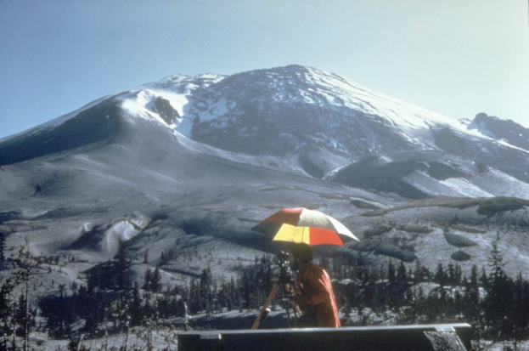

Changes in a volcano’s surface, such as a growing **bulge** or **tilting**, provides important information about the inner structure and workings of volcanoes. These changes include surface swelling, sinking, or cracking, which can be caused by **magma**, **gas**, or other fluids (like water) moving underground. Often, these surface changes are very small—a few centimeters (inches) or less—and so they can only be detected and monitored with very sensitive instruments. Peaks in data that show the amount of tilt often occur right before an eruption.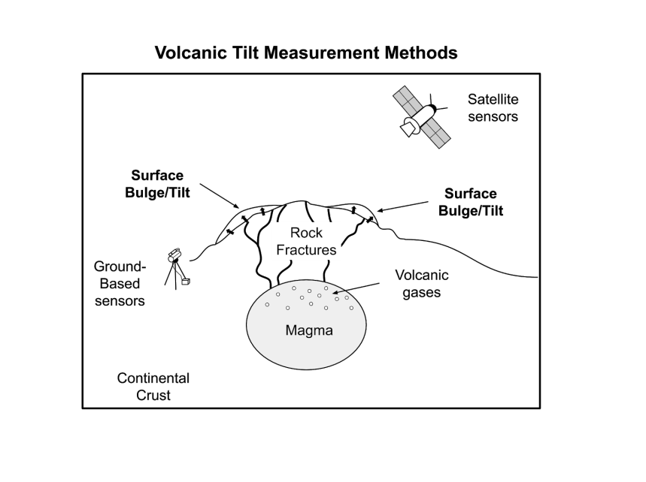

Scientists from the USGS Volcano Hazards Program install and maintain networks of ground-based sensors around volcanoes to monitor changes to the ground surface over time. Space-based observations of large areas are possible using satellite technologies.

**In the figure to the right, the blue dotted line shows the amount of surface tilt from an individual volcano over time. The solid triangles show when volcanic eruptions occurred. Scientists can compare changes in the amount of tilt to the times when volcanoes erupt for clues about what is going on inside a volcano.**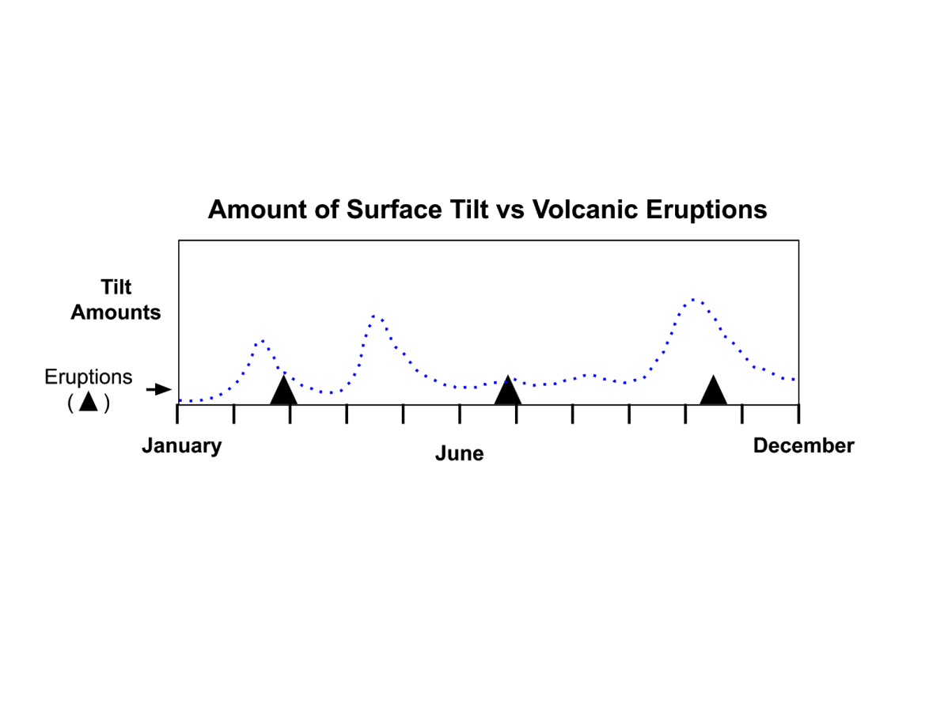

1. **Identify and describe any pattern(s) you see in the graph of “Amount of Surface Tilt vs Volcanic Eruptions”. For example, what are the changes in the amounts of tilt near the time of the eruptions?**

|  |
| --- |
|  |

**“Volcanic Earthquakes”**

Many processes in and around volcanoes can cause **earthquakes**. Most of the time, these earthquakes are caused by rocks breaking deep underground which do not lead to a volcanic eruption. However, volcanic earthquakes do occur as **magma** and **volcanic gases** rise to the surface through **rock fractures** (breaks in the rocks), which causes significant movements in the **crust**. Peaks in the number of earthquakes are often seen right before an eruption.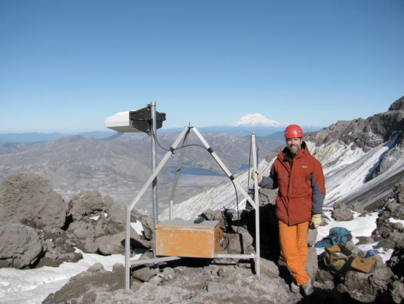

Most volcano-related earthquakes are too small to feel, generally quite close to the surface, and can occur in “swarms” consisting of dozens to hundreds of small quakes. Most swarms usually do not lead to eruptions, **but most eruptions are preceded by swarms**. Therefore, when there is an increase in earthquake activity at a volcano, scientists work around the clock to detect variations in the type, location, and intensity of earthquake activity to determine whether or not an eruption may occur.

**In the figure to the right, the pink dashed line shows the number of earthquakes from an individual volcano over time. The solid triangles show when volcanic eruptions occurred. Scientists can compare changes in the number of earthquakes to the times when volcanoes erupt for clues about what is going on inside a volcano.**

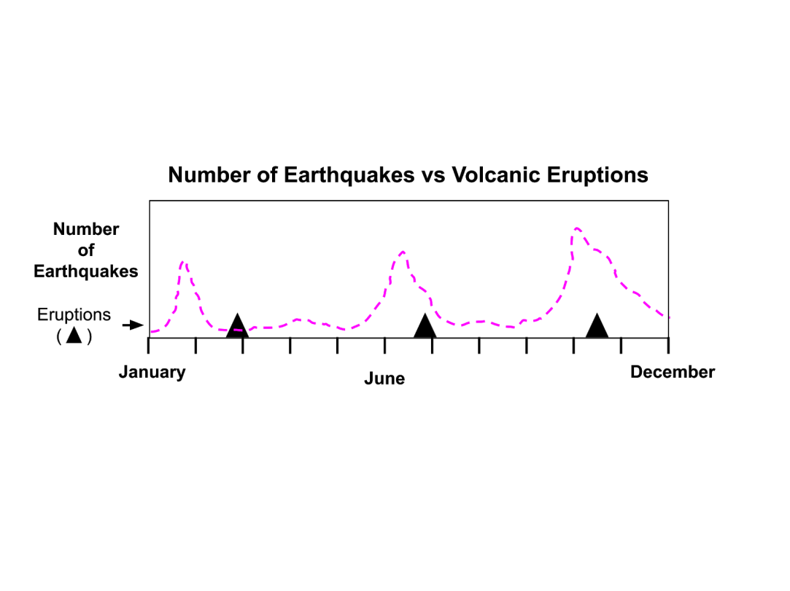

**4.** **Identify and describe any pattern(s) you see in the graph of “Number of Earthquakes vs. Volcanic Eruptions”. For example, are there changes in the amounts of earthquakes near the time of the eruptions?**

|  |
| --- |
|  |

1. **Study the image below, which shows the three sets of volcano monitoring data from the same volcano plotted on the same graph.**

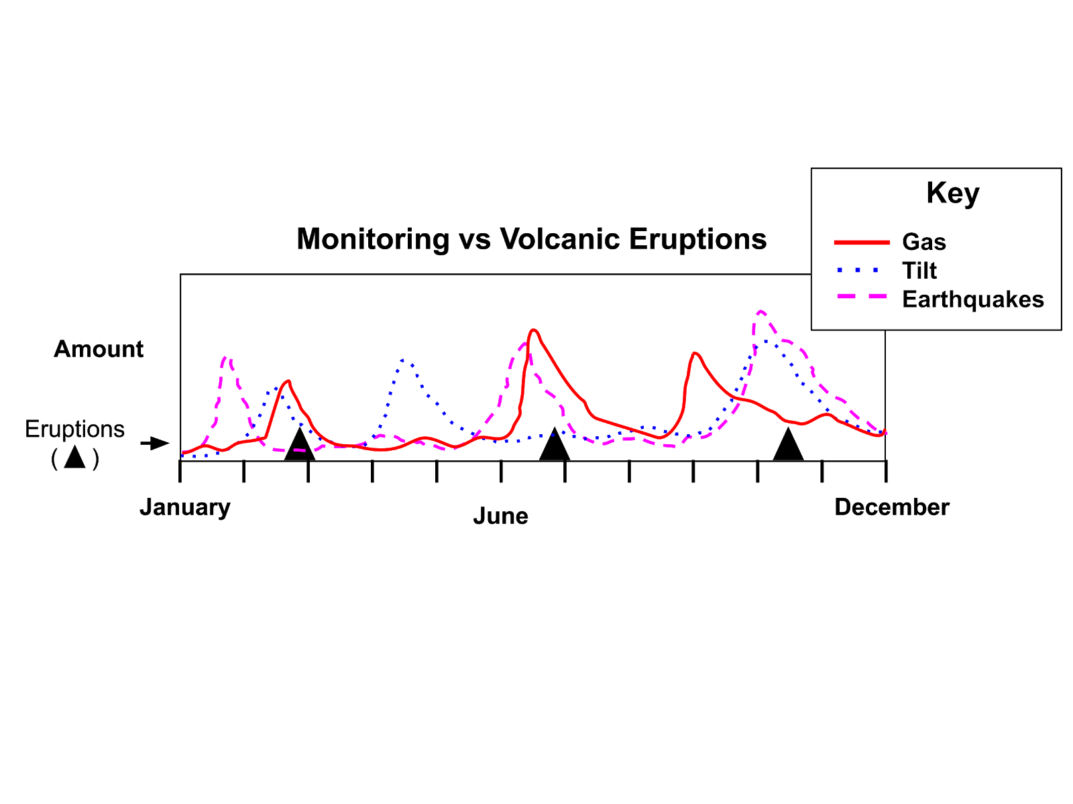

1. **Compare the times when volcanic eruptions occurred (black triangles) to periods when monitoring data peaked.  What patterns do you notice?**

|  |
| --- |
|  |

1. **Does having multiple types of data show any new patterns that help you to predict an eruption? Why or why not?**

|  |
| --- |
|  |

|  |
| --- |
| **Connect Your Ideas** |

1. Think about a process or event around your own home that is similar to the process of detecting volcanic eruptions.
   * Describe how you can use multiple types of observations to identify the everyday events below. (**Hint**: what senses (touch, smell, hear, etc.) do you use to detect what is happening?)
     + Example: A pot of water is on the stove. **What three observations would help you predict if it is going to boil?**

|  |
| --- |
|  |

* + - Is someone walking up to you from behind? A friend is walking up to you from behind. **What three observations would help you predict when they would reach you?**

|  |
| --- |
|  |