Name:________________________________________________________#:___Date:____________________________

Remote Learning Lesson 2:
Computational Thinking
- In your own words, what is the problem that needs to be solved?

- Circle one of the following distances which is closest to the amount of traveling Taylor travels using the simplistic view of Taylor’s house.
50-60 meters  60-70 meters  70-80 meters  over 80 meters | 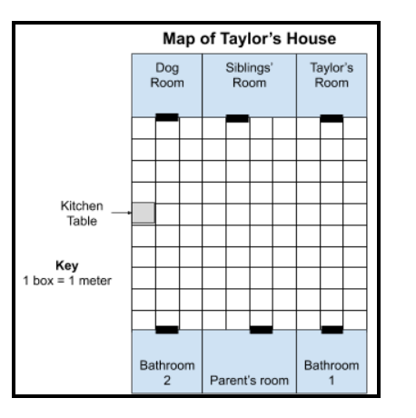

- Explain how you could improve Taylor’s plan of attack? Include how much distance your plan requires.

- Describe the engineering strategy engineers use, which is discussed in the article: Work Smart, Not Hard .

5. How does the order of the steps in your plan affect the overall solution?

6. Use examples from the text Algorithms, Algorithms Everywhere to explain if the order of the algorithms matter.

7. Make a list of 5 tasks you do in your everyday life that you could represent as algorithms (like we way in Taylor’s life).

1.
2.
3.
4.
5.

8. Pick your favorite task from question 7, make an algorithm to complete the task as quickly as possible.

9. Describe what makes your algorithm the quickest way possible?

