**Science Agenda: March 9th, 2020**

01. **Kahoot!** Get a computer right away!

02. **Science Test** on **Thermal Energy** tomorrow.

03. Did you do your **Study Guide**? You will need to give it to me tomorrow for credit.

04. Your **Research** typed & printed portion of your science experiment is due Wednesday. **This is summative!**

05. **Progress Reports** (signed & returned due by Wednesday!)

06. **Half-Day** this Friday ☺

**07. Please DONATE KLEENEX BOXES, HAND SANITIZER & CLOROX WIPES!**

**Social Studies Agenda: March 9th, 2020**

01. Did you do your **Great Wall of China Writing Prompt** & send it to via e-mail [kerrd@dearbornschools.org](mailto:kerrd@dearbornschools.org) (due today)

02. Cut/Paste **Vocabulary Words** in your **Interactive Notebook**

03. **Bell Work**

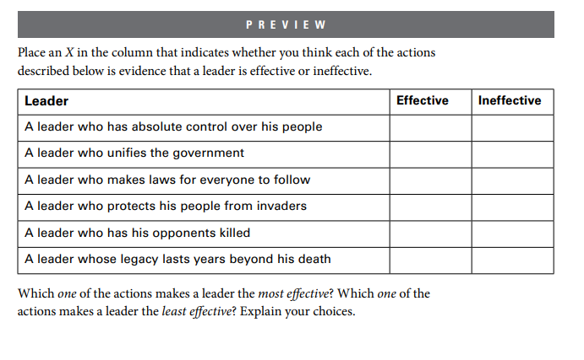

04. Get a **textbook turn to Chapter 22 page 233**

05. **The First Emperor of China** Packet we are doing this together

06. **Chapter 22 Illustrated Dictionary** due tomorrow

07. **Progress Reports** (signed & returned due by Wednesday!)

08. **Half-Day** this Friday ☺

**09. Please DONATE KLEENEX BOXES, HAND SANITIZER & CLOROX WIPES!**

|  |
| --- |
| **Qin Shi Haung:** the first emperor to rule (Qin Dynasty) a unified China, from 221 to 210 B.C., built The Great Wall and was a tyrant. |

|  |
| --- |
| **standardize:** to make all the same or constant. |

|  |
| --- |
| **censor:** to remove or suppress ideas considered harmful or dangerous. |

|  |
| --- |
| **immortal:** to live forever. |

|  |
| --- |
| **Great Wall:** a stone and earth wall about 1,500 miles long, first built during the Qin Dynasty to defend China’s norther border. |