**Science Agenda: February 27th, 2020**

01. **Bell Work:** Take a computer from the cart and go to the link below…

<https://sciencebob.com/science-fair-ideas/ideas/>

* *Write in your* ***Interactive Notebook*** *while we are looking at the site listed above; three things that you found useful for your upcoming experiment.*

02. Watch **YouTube Videos** <https://www.youtube.com/watch?v=cXJH9aM6ON0> (1:35) & <https://www.youtube.com/watch?v=vvRBNuOr6OI> (3:19)

* ***Compare and contrast the process the Wright Brothers used to the process you used to optimize your experiment.***

03. Go Over **“Race to Cool” Experiment**

04. Discuss Science Experiment Fair Ideas & Lab Report

* Be Fresh!
* Passing the “Huh” Test
* Understand It-It’s Yours Not Your Folks
* Prove Your Point
* Put Some Time In It (and have fun)
* Clear as Glass

05. Continue Working on Lab Reports (if time)

**Social Studies Agenda: February 28th & March 1st, 2020**

**Day 1:**

**Bell Work: (it’s on the table; put it in your Interactive Notebook)**

***01.)* What do you think was the purpose of building The Great Wall of China? And who built it?**

***02.)* What are some advantages and disadvantages of building The Great Wall of China?**

***03.)* What do you think The Great Wall of China is made of? Try to be specific.**

***04.)* How long to do you think The Great Wall of China is approximately?**

a.) 4,823 miles (about the same distance from Detroit to Moscow)

b.) 290 miles (about the same distance from Paris to London)

c.) 13,170 miles (about the same distance from Sydney to Rio de Janeiro)

d.) 2,787 miles (about the same distance from New York to Los Angeles)

***05.)* How long do you think it took to build The Great Wall of China?**

a.) over 1,500 years

b.) over 2,000 years

c.) over 3,000 years

d.) over 3,500 years

***06.)* Why is The Great Wall of China so important?**

***07.* Fact or Fiction? Can you see The Great Wall of China from space?**

**Watch YouTube Video** <https://www.youtube.com/watch?v=9dIyk65vR-g> (3:29) & <https://www.history.com/topics/ancient-china/great-wall-of-china> (2:14)

Start the **Station Activity** (3 stations out of 6 stations)

Do **BrainPop** and WKS on The Great Wall (if time)

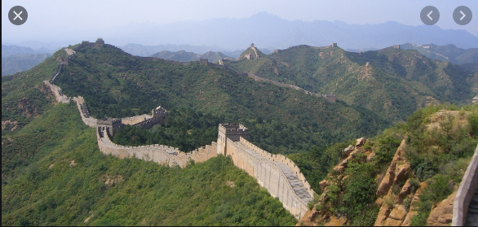

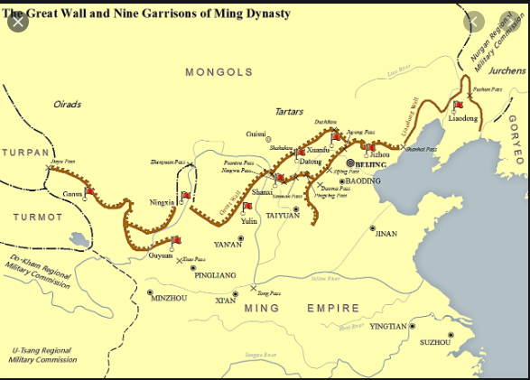

**Day 2:**

Collect BrainPop WKS (if not turned in from yesterday)

**Continue Station Activity: (10 minute stations) (3 out 6 stations)**

**Station #1:** Read *“The Great Wall of China”* article, annotate three things, highlight three words and answer the questions that follow.

**Station #3:** Draw a picture on your blank piece of paper of The Great Wall of China, be sure to include watchtowers, garrisons, fortress towers, entry way, flags, soldiers, the geography, etc. Also, be sure to use color.

**Station #4:** Word Search

**Station #5:** Using the Legos build to the best of your abilities your own Great Wall; try to include as much as you can and be as creative as possible.

**Station #6:** “Who Am I?” Write a 5-7 sentence paragraph on who is Qin Shi Haung and what is his importance? (textbook &/or computer may be used)

<https://www.chinahighlights.com/greatwall/>

<https://www.history.com/topics/ancient-china/great-wall-of-china>

Name(s):_____________________________#:____Date:_____________________________

**Ancient China Word Search (Station #4)**

|  |  |  |  |  |  |  |  |  |  |  |  |  |  |  |
| --- | --- | --- | --- | --- | --- | --- | --- | --- | --- | --- | --- | --- | --- | --- |
| D | V | P | H | B | W | O | A | I | H | Q | B | C | M | P |
| W | H | W | F | O | X | W | E | P | I | I | H | G | G | A |
| N | G | N | N | B | H | S | C | N | D | G | I | V | L | G |
| X | N | D | O | A | B | U | S | B | G | C | B | Q | P | O |
| Y | E | W | C | S | P | H | D | Y | N | A | S | T | Y | D |
| R | A | U | N | O | I | T | C | E | T | O | R | P | E | A |
| D | H | L | H | H | A | R | J | L | T | G | G | U | T | F |
| D | E | P | A | Y | C | R | R | H | Y | D | N | A | U | U |
| G | E | U | I | N | O | X | J | A | U | A | V | I | Z | N |
| F | N | F | I | R | I | K | K | O | G | O | L | Z | M | A |
| G | J | U | E | O | M | P | E | M | N | R | C | F | D | H |
| O | F | P | K | N | H | I | Q | F | T | K | H | R | J | X |
| Q | M | T | C | B | S | E | D | B | S | L | T | C | F | I |
| E | W | A | Z | Z | L | E | X | R | X | I | X | I | J | H |
| N | G | R | R | D | A | M | O | N | Z | S | J | Z | A | H |

Great Wall of China garrison emperor wonder

Dynasty pagoda Silk Road

Nomad Qin Shi Haung Han

Ming defense protection

**A History of the Great Wall of China (article: station #1)**

***Directions:*** *Read “The Great Wall of China” article and answer the questions that follow.*

In the third century B.C., China was divided into several states, which frequently fought among themselves. Large armies of foot soldiers, reinforced by smaller units of cavalry, crisscrossed the country. Protected by leather armor, these troops attacked the enemy with crossbows and beheaded each other with dagger-axes. Then, in 221 B.C., the king of the western state of Qin, from which the name "China" is derived, defeated all the other kingdoms. He became the First Emperor of China. His goal was to unify the lands under his control. To help do this, he standardized the Chinese characters, measures and weights so that all would be the same throughout the country. He also commissioned the building of great roadways and a long, massive wall.

**Let's Salute the Workers**

This was not the first wall to be built in China. Even before the Warring States period, some rulers had tried to protect their territories by constructing walls. These walls were made of rammed earth mixed with straw and brushwood. After the unification of China, the First Emperor sent soldiers, convicts and other men who had to fulfill their corvee labor obligation north to build his changcheng ("Long Wall").

Many died as a result of the difficult conditions. In some areas, they had to carry huge slabs of stone to the construction site and then pile them one on top of the other. In winter, it was extremely cold; in summer, very hot. Surviving letters and other records give witness to the suffering and sorrow of the ill-fated workers.

**Stay Out**

Why did the emperor of the unified China need such a wall if he had conquered all the warring factions within? The answer is simple—to protect him from a new enemy, one who lived even farther north. This new foe was the Xiongnu. These nomads had allied themselves into a powerful confederacy. They were raiding the farms of Chinese settlers living along China's northern border.

When the Qin dynasty was replaced by the Han, the Great Wall retained its importance. But it was not insurmountable. Watchtowers were built at regular intervals so that, in case of an attack, guards could use beacon fires to call other troops to their aid. In peacetime, markets were set up nearby. When merchant caravans passed through the Jade Gate Tower in present- day Gansu province, they left the civilized world of China and headed west along the routes of the far-reaching Silk Road.

**Bigger & Better**

Not every dynasty, however, needed to defend itself against invading nomads from the north. As a result, many sections of the old Great Wall fell into disrepair. Then, during the 15th century, when the Ming ruled China, a great effort was made to fortify the Wall. The Ming had succeeded in chasing the Mongols out of China. But these horsemen from the north were still a threat to the country's security. This was especially true after the Ming moved their capital from the south to the north, to Beijing. Still, it was only after 1449, when a group of Mongols captured the Ming emperor and defeated a huge Chinese army, that the Ming decided to build a new Great Wall.

More than 40,000 men were enlisted for the first phase of its construction. Regional military commanders were assigned to **supervise** the construction of **individual** sections. A close look at the bricks used to build the wall offers much information. The inscriptions on many of them tell not only the date they were made but also where they were made.

This new wall also clearly **acknowledged** Mongol control over the area north of the Ordos Desert. It did so by following the southern border of the Ordos and then bordering the bend of the Yellow River that lay north of the Ordos as the first Great Wall had done.

**Gigantic**

In recent years, many sections of the Wall have undergone repair. Still, our image of the Great Wall is shaped by the structures built during the Ming dynasty. To be sure, it was, and still is, an impressive structure. More than 4,970 miles long, it starts at Jiayuguan, the westernmost fortress by the Gobi Desert. It then follows the ridges of the mountains in the north as it stretches east and ends at Shanhaiguan, the easternmost fortress by the Yellow Sea.

The Great Wall is not just one wall. In some places, there are several lines of walls. It is also not just one height or one width throughout. On average, it is about 23 feet wide and more than 32 feet high. Even more impressive were the many beacon-fire towers and fortresses.

**Treachery**

In the end, the Great Wall did not help the Ming. In 1644, a general named Wu Sangui opened the gates at Shanhaiguan and let in the Manchu, yet another tribe of hunters and fishers from the northeast. Wu Sangui's act led to the downfall of the Ming. The Manchu established the Qing dynasty, the last in China's history.

Today, the Great Wall remains an important **symbol** of China's might. It is also World **Heritage** Site and a top attraction for tourists from around the world.

**A History of The Great Wall of China (questions)**

01. Which detail from the article explains why some parts of the Great Wall were in poor condition?

02. Which sentence from the article describes the current purpose of the Great Wall?

03. Re-Read the introduction [paragraph 1]. How does this section contribute to the article's MAIN idea?

04. Re-Read the section "Bigger And Better." What does this section explain that other sections do not?

05. What new or surprising information did you learn from this article? What does this information make you wonder about?

**Period 5 Groups:**

**Station #1: Station #2: Station #3:**

Batoul Buckr Ali F.

Lena Hadi Angie

Lola Hussein Jumana

Aya Claire Husayn

Amna Kenly

**Station #4: Station #5: Station #6:**

Amira Muhammadali Connor

Timia Yousef Mahdi C.

Najla Zahraa Hannah

Mia Jana Ryan

Reem

**Period 6 Groups:**

**Station #1: Station #2: Station #3:**

Talia Madison Anmar

Abdullah Jasmine Mohammed

Amani Nour Rabie

Niemer Donna Houssam

Mehdi A. Fida

Medina

**Station #4: Station #5: Station #6:**

Ali R. Karim Zainab

Malik Mazin Hajar

Ahmmad Yara Zak

Zayn Hawraa Hassan