**Name:________________________________________________#:_____Date:________________________**

**Geography Study Guide for Chapter Test**

01. Define **geography** and what are the **two types of geography**?

Geography is the study of people and places. There are two types of geography: physical and human.

02. What is the difference between **urban** and **rural**?

Urban means the city while rural means the country.

03. Define **map**, **globe** and **compass**.

Map is a flat two dimensional surface that shows places, cities, landforms, borders, bodies of water, etc. while a globe is sphere shape and three dimensional and shows the same. A compass shows directions: north, south, east and west.

04. What is the difference between **latitude** and **longitude**?

Both are imaginary lines on Earth measured in degrees however latitude lines go east to west while longitude lines go north to south and connect at the poles.

05. What is the differences between a **push** and **pull factors**? Give three examples for each.

Push factors are negative reasons why you leave somewhere like loss of a job, no access to resources, , high crime rates, war or persecution while pull factors are positive reasons what gets you to live somewhere like a new job or new house, safer neighborhood or better schools.

06. Know where all **seven continents** and all **five oceans**. Know where the **equator** and **prime meridian** are. Be able to label them on map that looks similar to the one below on the test.

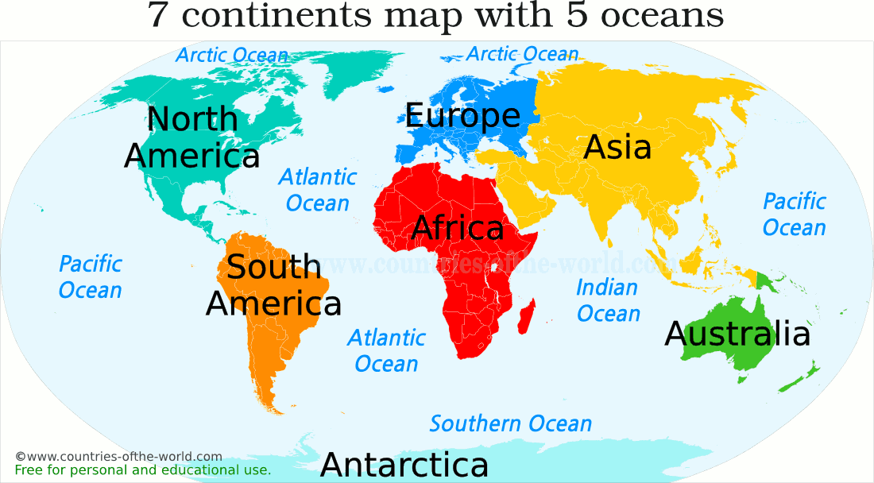

07. What is the difference between **weather** and **climate**?

Weather is happening now while climate is measured over time.

08. Define **population** and **population density**.

Population is the number of people in any given area while population is the average amount people is a specific area.

09. What are the three **most populated cities in the U.S**.? What is the **most populated city in the world** & what are the **three most populated countries in the world**?

1. New York-NY, 2. Los Angeles-CA, 3. Chicago-IL

1. Tokyo-Japan

1. China, 2. India, 3. United States

10. Give three reasons why people are living longer now in 2018 than they did 100 years ago.

Better medical care, more access to food and water and better housing (construction).

11. Why isn’t a **Mercator Map** really as accurate opposed to a **Robinson Map**? What is the difference between a **Political** and a **Physical** **Map**?

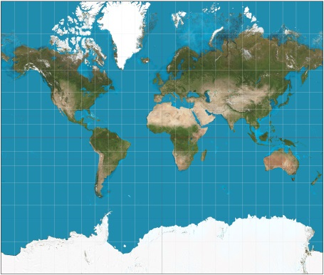 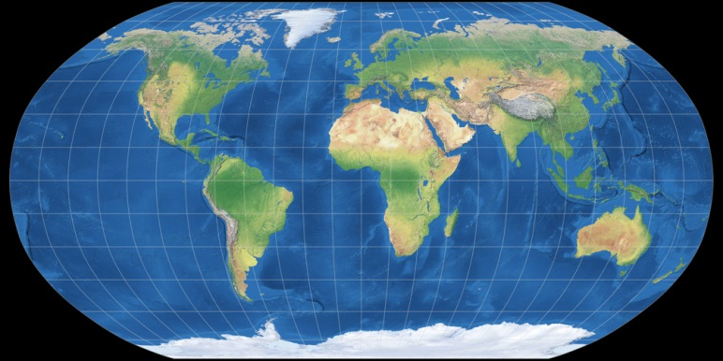

Mercator Map is square and countries in the poles are distorted such as Greenland, while a Robinson Map is curved on the sides and does not have that effect.

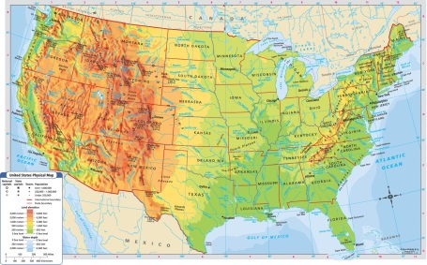 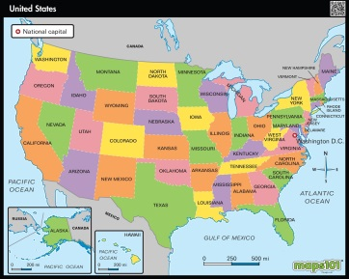

Physical Map shows landforms and a Political Map shows borders usually in pretty colors.

12. What do **surveyors**, **historians**, **political scientists**, **sociologist**, and **economists** do?

-measure & map the land

-study historical events & people

-study government & laws

-study culture & religion & society

-study money, GDP, import/export & supply demand

13. Define **hemisphere** and where are they on a map?

Hemisphere is half of a sphere. There are four northern, southern, eastern & western.

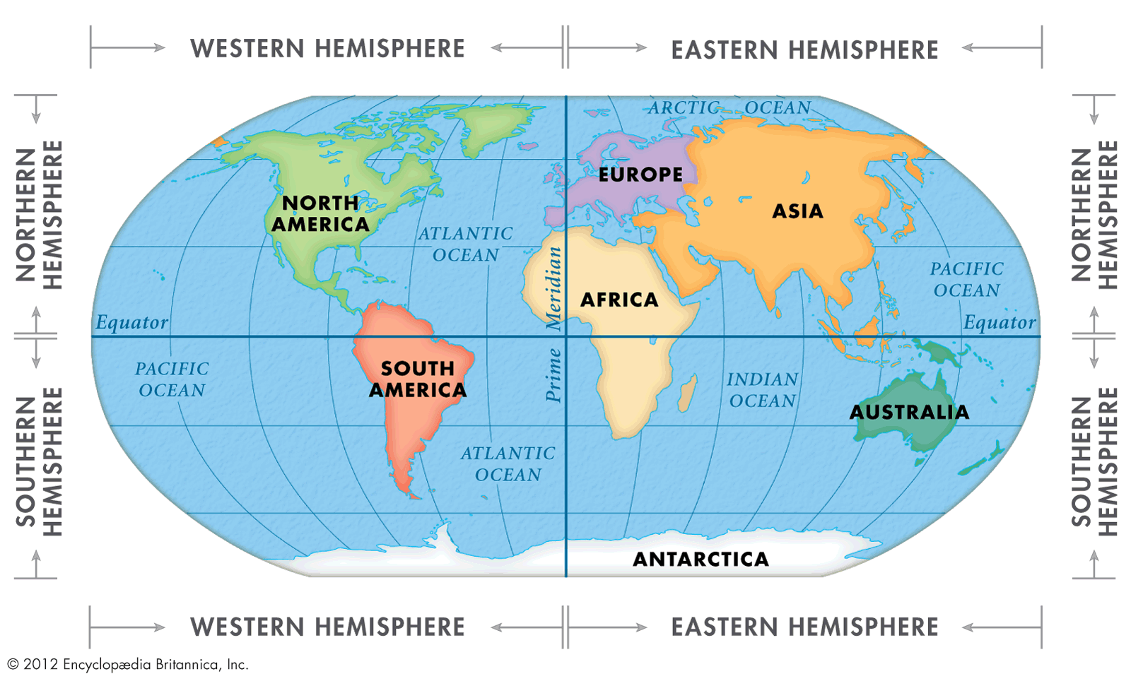

14. Define d**egree (°).**

The unit of measurement used for longitude and latitude.

15. What does **global** mean? Give three **global** issues.

Global means across the world something that effects everyone such as poverty, climate change, world peace & overpopulation.

16. What are the three major **landforms**?

The three landforms are mountains, plains and plateaus.

17. What is **Global Position System (GPS)?**

Global Positioning System or GPS is a global system of U.S. navigational satellites developed to provide precise positional and velocity data and global time synchronization for air, sea, and land travel.

18. What are the **5 Themes of Geography**?

**M**ovement

**R**egion

**H**uman **E**nvironmental Interaction

**L**ocation

**P**lace

Remember Mr. Help.

19. What is **Geography Inquiry**?

Ask, acquire, organize, analyze & answer (AAOAA)

20. Be able to use **longitude** and **latitude** and finding the **coordinates** on a map of a specific location.

21. Know when this Study Guide is due & know when your unit test is.

**Study Guide is due Friday November 2, 2018 and Test is Wednesday November 7, 2018.**