Name:_____________________________________________#:___Date:_______________________________________

**Study Guide for Chapter 1: Cells-The Basic Units of Life & Chapter 2: The Cells in Action**

01. Label these parts on the animal cell below: **nucleus, nuclear membrane, mitochondria, cell membrane, ribosomes, endoplasmic reticulum, cytoplasm, and golgi complex.**

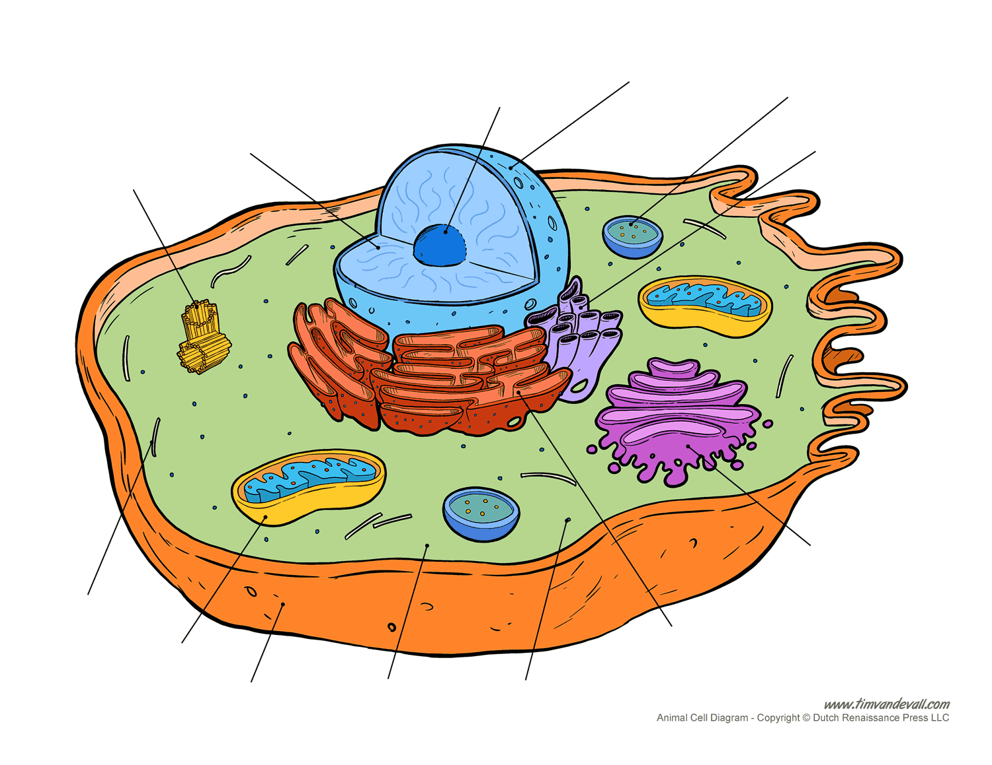

02. What are **three** main differences between an animal cell and a plant cell?

03. Put in sequence order:

**_____Anaphase _____Prophase _____Cytokinesis _____Interphase _____Telophase _____Metaphase**

04. What is the difference between **osmosis** & **diffusion**?

05. Things that have ALL the characteristics of life are called what?

06. **True or False:** Humans have over 100 trillion cells.

05. Put in sequence order:

**_____Tissues _____Organs _____Organism _____Cells _____Organ Systems**

**Part 1: Matching:**

**01._______Nucleus A.)** the organelle that makes lipids, breaks down drugs and other

substances and packages proteins for the Golgi Complex.

**02._______Ribosome B.)** the organelle that stores water and other materials; similar to a

vesicle.

**03._______Cytoplasm C.)** the organelle that breaks down food molecules to ATP and helps

with cellular respiration.

**04._______Cell Wall D.)** the organelle that digests food particles, gets rid of wastes, cell parts

and foreign invaders.

**05._______Cell Membrane E.)** the organelle that contains the cell’s DNA and is the control center of

the cell; the brain.

**06._______Endoplasmic Reticulum F.)** the organelle that uses the energy from sunlight to make food; only

in plant cells.

**07._______Mitchondria G.)** a layer that covers a cell’s surface; acts as a barrier between the

inside of a cell and the cell’s environment.

**08._______Chloroplast H.)** inside the cell is a jelly like fluid that enables all the organelles to

move around.

**09._______Gogli Complex (Bodies) I.)** the organelle in which amino acids are hooked together to make

proteins.

**10._______Vacuole J.)** the organelle that processes and transports proteins and other

materials out of the cell.

**11._______Lysosome K.)** a rigid structure that surrounds the cell membrane and provides

support; only in a plant cell.

06. All living things need six things for survival. Name three of them.

07. From the Latin word *cellula*, cell means ____________________.

08. The abbreviation for deoxyribonucleic acid, an organism’s genetic material found in cells is what?

09. Most dividing human cells normally complete the cell cycle in about how long?

a.) 12 hours, b.) 24 hours c.) 36 hours d.) 48 hours

10. How many chromosomes does the average human have?

11. What are three examples of **fermentation**?

12. Are groups of similar types of cells that work together to carry out specific tasks; comes from Latin meaning “weave” and connective, muscle and nervous are examples.

13. Are groups of different tissues working together to perform a particular job; examples are heart, lungs and kidneys.

14. Are groups of different organs that work together to complete a series of tasks; examples are digestive, nervous and circulatory.

15. In biology, the smallest unit that can perform all life processes is called what?

a.) atom, b.) micro-organism c.) cell d.) droplet

16. **True or False:** The Cell Theory states that all living things are made of one or more cells and that all new cells come from preexisting cells.

17. A membrane-surrounded component (part) of a eukaryotic cell with a specialized function is called what?

18. What are the advantages and disadvantages of multicellular organisms vs. unicellular organisms?

19. Explain **photosynthesis** and draw a picture.

21. Define **cellular respiration**.

22. In a reaction that eukaryotic and prokaryotic cells can use to obtain energy levels from food when oxygen levels are low is called what?

23. A rod-shaped cellular structure made of condensed chromatin; contains DNA, which carries the genetic information that controls inherited traits is what?

24. How many stages of mitosis are there?

a.) 1 b.) 2 c.) 3 d.) 4

25. Of all the stages of the cell cycle which one takes up the most time (90%)?