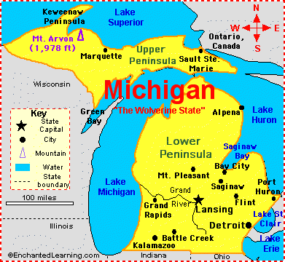**Unit 1 Study Guide**

1 . Practice using a map of Michigan and a compass rose to practice with direction you are going from one city to another . For example what direction are you traveling if you go from Grand Rapids to Lansing.

2. People in MI live mainly in southeastern MI because there are more jobs. TRUE/FALSE

3. Practice naming the Great Lakes and know their locations. Remember HOMES

**H**uron

**O**ntario

**M**ichigan

**E**ric

**S**uperior

4. What will happen if we dump trash in our water?

_________________________________________________________________________________________________________________________________________________________________________

5. Natural Resources are things that we uses that come from nature. Trees, Minerals, cows, pigs, fish and deer are all natural resources. List 3 more natural resources:

1. ___________________________

2. _________________________

3. __________________________

6. What are some of the cities in Wayne county?__________________________________________ Draw a circle for put Dearborn in middle, then Wayne county, then Michigan, then United States, then North America then the world.

7.This map show the bridges to Canada. This is an example of how human characteristics are used to connect places. What are the names of the 3 bridges on the map:

1.___________________________________________________

2.___________________________________________________

3.___________________________________________________



8. This is a map of the orchards of Michigan. Why do you think they are all on the west coast of Michigan.



9. How can we divide Michigan into 2 regions?

10. What does the map below show us? - The Northern Lower Peninsula has fewer people. Why would the northern lower peninsula have less people than the southern lower peninsula?



11. Look at the map below. What region of the United States does Michigan belong to?



12. Michigan trades sells its apples and other products to other states. Florida sells its oranges to other states. Why do we this?

13. People might leave Michigan to find another job or find a warmer places to live. Why would they do this?

14. A new Ford plant will bring new jobs. How is this helpful to Michigan?

15. How could California scientists can help Michigan scientists solve the zebra mussel problem?

16. What is tourism?

17. How can the Michigan Great Lakes create jobs because of tourism?

18. How can people change their environment by cutting down trees to build houses?

19. List 2 Positive reasons for using water

1.

2.

List 2 negative reasons for using water

1.

2.

20. List 2 Positive reasons for using forests

1.

2.

List 2 negative reasons for using forests

1.

2.

Label the Great Lakes - you can use the map on page 1 to help you if you forget where they are:

