Name: __________________

**Grade 3: Unit 6 Pre-Test**

**Which statement(s) are true about the figure below?**  3.G.1

1) The shape is a parallelogram. Yes No

2) It has one set of parallel lines. Yes No

3) There are no right angles. Yes No

4) **Draw a quadrangle with two right angles and one set of parallel sides. Label the points. Use the right angle symbol to show the right angles.** 3.G.1

5) **Write 2 facts about the shape below.**  3.G.1

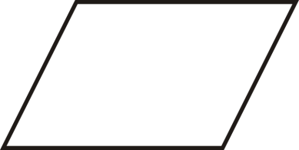

Fact 1:________________________________________________________________________

Fact 2:________________________________________________________________________

**There are 5 stations in math workshop. Each station has 5 students. Which number model(s) show how many students there are in all?**  3.OA.3

6) 5 + 5 + 5 + 5 Yes No

7) 5 x 5 Yes No

8) 2 x 5 Yes No

9) **You have 18 pencils and you want to share them equally with yourself and 2 friends. How many pencils will each of you get?**  3.OA.3

Draw a model.

Write an equation: _______________________________

10)

**Use the diagram to help you solve the problems below. Record you answer with a unit. Write a number model.** 3.OA.3

10) Linda has 48 crayons to put into boxes. 8 crayons fit into each box. How many boxes does she need?

|  |  |  |
| --- | --- | --- |
| **Boxes** | **Crayons**  **Per box** | **Crayons**  **In all** |
|  |  |  |

Number model: _____________________________ Answer: ______________________

(units)