Name: ____________________

3rd Grade: Unit 3 Pre-test

Measure the line segment to the nearest inch. 3.MD.4

1) 4 inches Yes No

2) 4 ½ inches Yes No

3) 5 inches Yes No

The students in the class are using ribbon for a class project. Use the data from the tally chart to create a line plot. 3.MD.4
4)

Measure the sides of the polygon to the nearest ½ inch. Write the measurements by each side.
3.MD.4/3.MD.8

5) The perimeter of the shape measures _____________ inches.

Which rectangles have an area of 15 square units? 3.MD.5 / 3.MD.6

6) Yes No

7) Yes No

8) Yes No

9) Draw a rectangle with an area of 20 square units. 3.MD.5/3.MD.6

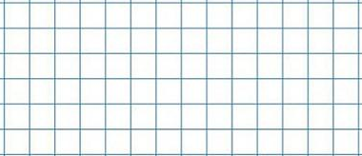

10) What is the perimeter of the rectangle you created? ________ units 3.MD.8

11) Do these two rectangles have the same area? 3.MD.5/3.MD.6

Explain your answer.
______________________________________________________________________________

______________________________________________________________________________

Which number model shows the area of this shape? 3.MD.7

12) 6 x 4 Yes No

13) 4 x 5 Yes No

14) 4 x 6 Yes No
15) Draw a 2 x 8 and a 3 x 5 rectangle on the grid paper. 3.MD.7

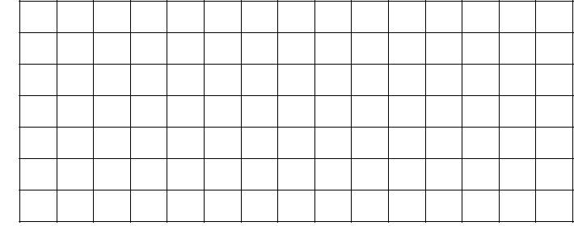

16) Which rectangle has more area? Explain how you know. 3.MD.7

________________________________________________________________________

________________________________________________________________________

Which polygons have a perimeter of 16 inches? 3.MD.8

17) Yes No

18) Yes No

19) Yes No

