Name: _____________________________

**3rd Grade: Unit 2 Study Guide**

**Jessica collected 25 soda cans on Sunday and 17 on Monday. How many soda can does Jessica have?**  3.OA.8

Which number model can be used to find the solution?

1) 17 + _____ = 25 Yes No

2) 25 - 17 = _____ Yes No

3) 25 + 17 = ____ Yes No

4) **Devon came to school with 48 pencils. He gave some of his pencils away. He now has 32 pencils. How many pencils did he share with his friends?** 3.OA.8

**Total**

**Part**

**Part**

5) Write a number sentence: ______________________ Answer:____________

**Which of the following number models have an answer of 185?** 3.NBT.2

6) 100 + 50 + 25 Yes No

7) 90 + 90 + 5 Yes No

8) 200 – 10 - 5 Yes No

9) **Find the sum.** 3.NBT.2

18 + 25 + 2 = _________

I added in this order: ____________________________________

10) **Solve.** 3.NBT.2

382 + 441 = _______

Explain the strategy you used to solve the problem.

______________________________________________________________________

**Complete the tables.** 3.OA.9

11) 12)

|  |
| --- |
| Rule: |
| - 5 |

|  |
| --- |
| Rule: |
| + 2 |

|  |  |
| --- | --- |
| **In** | **Out** |
| 16 |  |
| 46 |  |
| 96 |  |

|  |  |
| --- | --- |
| **In** | **Out** |
| 8 |  |
| 38 |  |
| 68 |  |

13) **Write the next number in the pattern.** 3.OA.9

18, 22, 26, 30, ______

Explain the pattern. ______________________________________________

Addition Chart: 3.OA.9

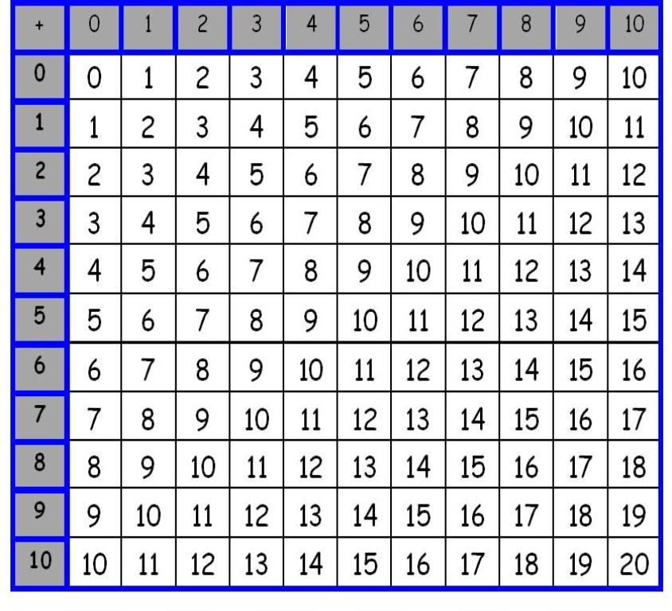

14) Explain what is always true about the sum when adding an even and an odd number together.

___________________________________________________________________

15) What is always true about the sum when you add 2 odd numbers together?