Abdulkarim, Medina | French Fur trader
Abuhmaid, Yazeed | Johnny Appleseed
Badaoui, Fatima | French Fur trader
Bahmad, Hadi | Paul Bunyan
Elawad, Ariana | Father Marquette
Hachem, Yusef | Erie Canal
Leah Rustom | Native American
Mackie, Hani | British Soldier
Mawari, Amalia | French Fur trader
Obeid, Hiba | Pioneer
Quam, Jonathon | British Soldier
Zahr, Soukayna | Native American
Ahmed, Alexander | Erie Canal
Ald, Brenna | Sleeping bear
Bazzi, Sukayna | Native American
Haidar, Aref | Chief Pontiac
Kayed, Ameer | Davy Crockett
Nikolajevs, Natalie | Erie Canal
French Fur Trader  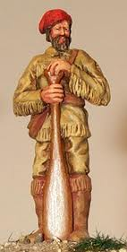 | British soldier  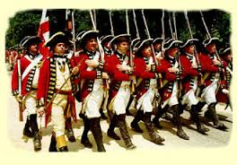

Eric Canal passengers  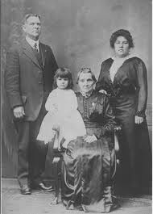 | Eric Canal workers  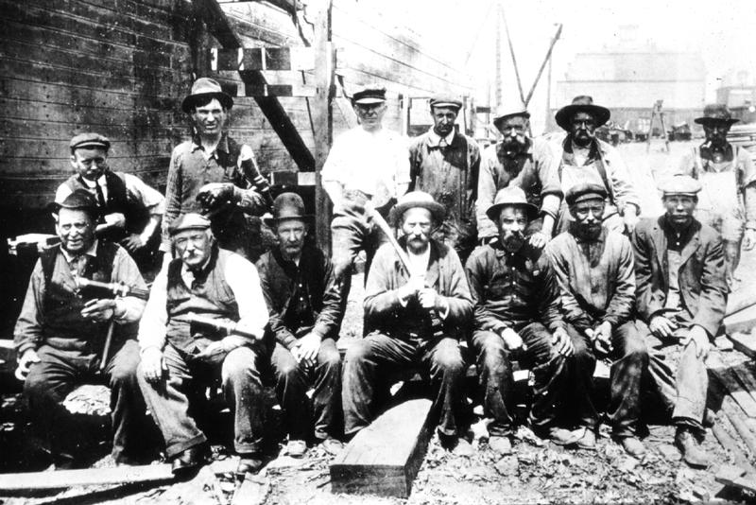
Paul Bunyan  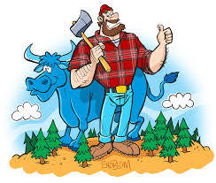 | Johnny Appleseed  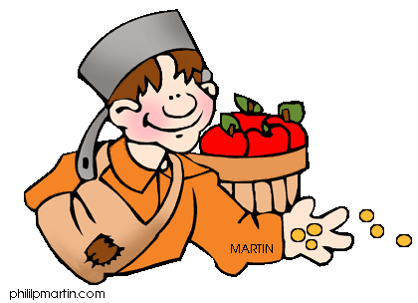
Davey Crocket  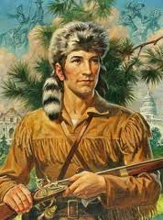 | Father Marquette  