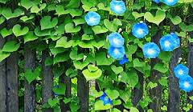 | 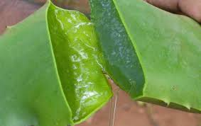  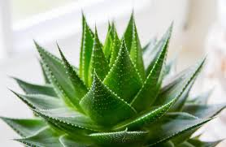
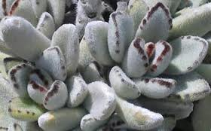 | 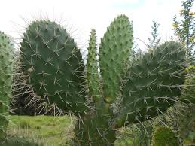
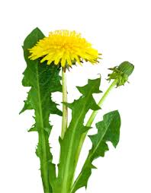  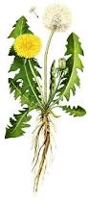 | 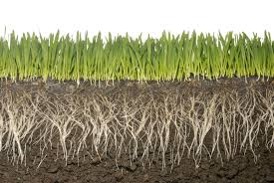  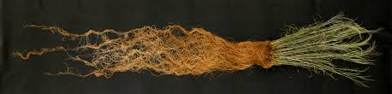
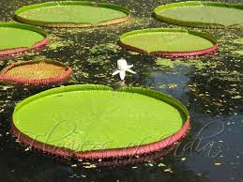  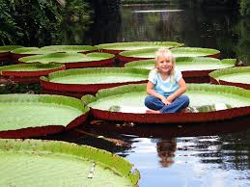 | 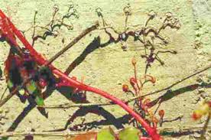  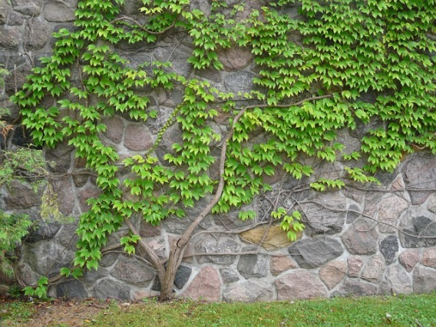
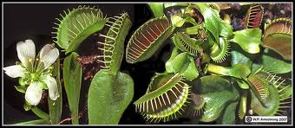  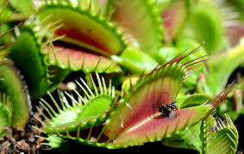 | 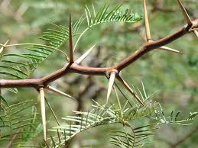  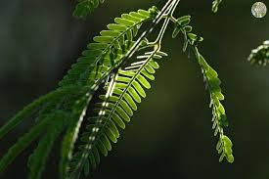  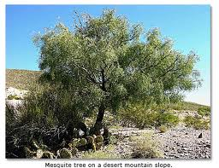
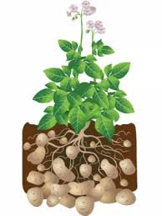  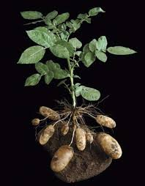 | 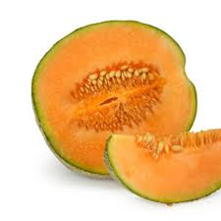  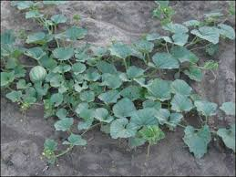
Things you can’t see in the picture . . .  - Name: Aloe Vera  - Thick, waxy leaf covering  - Lives in dry envirnoments | Things you can’t see in the picture . . .  - Name: Morning Glory  - Poisonous  - Grows along fences or other taller objects
Things you can’t see in the picture . . .  - Name: Cactus  - Roots are big, long and shallow  - Green parts are the stem  - The sharp spikes are a special kind of leaf  - Grows in dry, hot environments | Things you can’t see in the picture . . .  - Name: Panda Ear Plant  - Grows in dry areas  - The dark brown bumps on the tip of the leaf can develop into roots
Things you can’t see in the picture . . .  - Name: Switchgrass  - Grows in dry windy prairies | Things you can’t see in the picture . . .  - Name: Dandelion  - Milky liquid in the leaves and stems
Things you can’t see in the picture . . .  - Name: Boston Ivy  - Sticky liquid comes out of the circular pads  - Grows next to taller objects in the areas with lots of vegetation | Things you can’t see in the picture . . .  - Name: Giant Water Lily  - Large spikes sticking out of the bottom of the leaf  - Air filled sacks in the leaf
Things you can’t see in the picture . . .  - Name: Mequite Tree  - Leaves fold together during dry times  - Grows in dry environments | Things you can’t see in the picture . . .  - Name: Venus Fly Trap  - Leaves fold together on insects  - Digestive liquid inside leaf
Things you can’t see in the picture . . .  - Name: Cataloupe  - Have bright yellow flowers | Things you can’t see in the picture . . .  - Name: Potato Plant  - Have poison in the leaves, stems & roots  - Cooking at high temperatures destroys these poisons

Plant Part Card Game Student Pages
 | Describe . . . .  the plant’s structures and functions | Explain . . . .  how these structures and functions help it survive
Blue
Heavenly Morning Glory

Aloe Vera

Panda Ear
Plant

Cactus

Dandelion

Switchgrass

 | Describe . . . .  the plant’s structures and functions | Explain . . . .  how these structures and functions help it survive
Giant Water Lily

Boston Ivy

Venus Fly Trap

Mesquite Tree

Potato

Cantaloupe Plant

Plant Card Game Teacher Pages

Teacher Information Key: (the information in the sections below was compiled using various websites)
Blue heavenly morning glory is a robust herbaceous perennial. Because of its aggressive climbing habit, it is able to twine around other trees and shrubs out-competing them for sunlight. It can also spread into natural areas choking out and smothering native plants. The deep root system extends in many directions allowing the plant to spread and establish in new areas competing with other plants for nutrients and water. Once established, it is very difficult to eradicate the plant. Vegetative fragments of the plant, including shoots and roots, are often dumped with garden wastes, thus spreading the plant further. The climbing capability along with its reproduction and spreading habits can seriously hinder the growth process of host plants, and decrease biodiversity in the surrounding environment. | 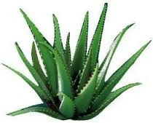  Aloe plants grow far away from each other. The plants that survive in the desert compete for the small amount of water available, and so they cannot grow close together.  Aloe has deep roots that are very efficient at absorbing a lot of water in a short amount of time (The desert has short, intense rain storms). The fat, fleshy, spongy leaves absorb water quickly and hold water longer. Plants with these fat leaves are called succulents.  Thorns on the edge of the plant keep animals from eating the plant to get to the water stored inside.  The leaves are waxy (like a candle) to keep water inside. The wax layer acts like a plastic wrapper.  The leaves are shiny and smooth to reflect the sun light away from the plant and keep the plant cooler.  The plant self-shades. This means that the top leaves are larger and create shade for the tender young leaves growing underneath.  Some aloes have leaves that fold in during the hot summer months. This helps to protect the softer and younger leaves for extreme temperatures. Leaves open again in cool weather.  The flower of the aloe attracts birds and insects that pollinate the plant. The aloe produces many winged seeds that are easily spread far and wide by the wind.
The dense covering of plant hairs performs a vital function for the Panda Ear plant in the form of water conservation. In the dry environment in which it lives, panda plants must conserve what little water it can absorb from the soil. The dense mat of hairs growing from the leaf slows the movement of air directly across the leaf surface, therby reducing water vapor loss (transpiration). The “dead air” space created by the numerous hairs insulates the leaf from its harsh external environment, too. In addition, the white-silver appearance of the leaves reflects light, lessening the chances of the leaves overheating. | With few exceptions, cacti are succulent plants and, like other succulents, they have a variety of adaptations that enable them to survive in hot and dry environments.  In most species of cacti, the leaves have evolved into spines which not only defend the cacatus against herbivores but also provide shade that lowers the plant’s water loss through transipiration. The spines grow from specialized structures called areoles, homologous to the nodes on other plants. Enlarged stems carry out photosynthesis and store water. Unlike other succulents, the stem is the only part of many cacti where this takes place. Cacti often have a waxy coating on their stems to prevent water loss and potentially repel water from their stems. Because of the plant’s high water-retention ability, detached parts of the plant can survive for long periods and then grow new roots from anywhere on the plant body when rain comes.  The bodies of many cacti have become thickened during the course of evolution and form water-retentive tissue that is in the optimal shape of a sphere or cylinder (combining highest possible volume with lowest possible surface area). By reducing its surface area, the body of the plant is also protected against excessive sunlight. The plant body itself is also capable of absorbing moisture (through the epidermis and the thorns), which is especially important for plants that receive most of their moisture in the form of fog.  Most cacti have a short growing season and long dormancy. This is helped by the ability to form new roots quickly. Two hours after rain following a relatively long drought, root formation begins in response to the moisture. Apart from a few exceptions, an extensively ramified root system is formed, which spreads out beneath the surface. Cacti often have very shallow roots that spread out widely and close to the surface to collect water, an adaptation to infrequent rains.

Teacher Information Key: (the information in the sections below was compiled using various websites)
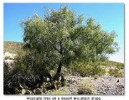  Mesquite has an extremely long root system to draw water from deep underground near the water table.  The tap root of the Mesquite can reach 40 to 160 feet underground.  Plants grow far away frome ach other. The plants that survive in the desert compete for the small amount of water available and so they cannot grow close together.  Sharp, long, strong thorns keep animals from eating the plant. These thorns are so strong, they can go through sneakers.  The leaves are small to conserve moisture. | A magnificient example of adaptation to weedy life in perennial grassland is provided by the common dandelion. Taraxacum officinale. In addition to its deep taproot and rosette of leaves, which help it to deal with competition of the grasses, it has remarkable powers of regeneration from any part of the rootstock which may be servered. The flat rosette of leaves avoids the blade of a mowing machine and it is not easy for a grazing animal to consume them, while the more exposed flowering scape is richly provided with unplatable latex (the white milky substance in the stem does not taste good). The leaves are very bitter tasing so few animals will eat them. The inflorescence buds are produced very near the ground level and develop rahter slowly in this position (from which they will not be cut even by a very fine-set lawn mower). Suddenly the scape elongates and flowering and frut-setting takes place rapidly (assisted by precocious development of the apornmicatically-produced enbyos).  The dandelion produces seeds mainly in the spring but continues throughout the summer and fall. Their small parachute like seeds mean that they can be blown many miles from the mother plant. Dandelions don’t mind being trampled meaning they can survive where people walk. All of these features are characteristic of the genus Taraxacum as a whole and must be looked upon as preadaptations to weediness.
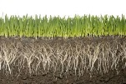  Switchgrass is a hardy, deep-rooted, perennial rhizomatous grass that begins growth in later spring. It can grow up to 2.7 m high, but is typically shorter than big bluestem grass or indiangrass. The leaves are 30-90 cm long, with a prominent midrib. Switchgrass uses C₄ carbon fixation, giving it advantage in conditions of drought and high temperature. Switchgrass is a versatile and adaptable plant. It can grow and even thrive in many weather conditions, lengths of growing seasons, soil types, and land conditions. Switchgrass is both a perennial and a self-seeding crop, which means farmers do not have to plant and reseed after annual harvesting. Once established, a switchgrass stand can survive for ten years or longer. Unlike corn, switchgrass can grow on marginal lands and requires relatively modest levels of chemical fertilizers. Overall, it is considered a resource-efficient, low-input crop for produing bioenergy from farmland. | 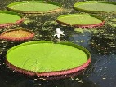  The scientific name of this organism is Vitoria amazonica. The common name for this organism is Giant Water Lily.  The flower of this plant is white and only blooms at night. The color of the lily, however, changes when it is pollinated to a pinky purple. When the lily is still white in color and needs to be pollinated, it gives off a butterschotch and pineapple scent that attract the beetles that pollinate the flower; another way the lfower attracts beetles is its power to heat up the core of the flower. If the heat outside is 85⁰C then inside the lfower can be up to 95⁰C. The flower is approximately the size of a soccer ball and only lives for three days.  The most interesting thing about this flower is the large leaves that it creates. The leaves can grow up to 46 cm in size and can hold up to 135 kilograms or nearly 300 pounds. The leaves are flat before growing rims at the edge of the leaf. The leaves are strong and stiff thanks to the strong bottom of the leaves. The bottoms are covered with spines to help support the ribs. It only grows and reproduces in warm climates.  The giant water lily adapts to the environment by growing thorns on the bottom of the leaves to protect itself from fishes and other predators that might want to eat it. Another adaptation is the rim around the edcges of the leaves. These rims help protect the leaf from birds and insects that might want to eat the leaves (the rim is a barrier between the insects and the leaf). The third adaptation of the Giant Water Lily is that the flower only lives for three days. It traps the beetles that come to pollinate the flower inside its core and then releases all its pollen on these beetles. This enlarges the percentage of pollen that gets transported to other flowers for pollination.

Teacher Information Key: (the information in the sections below was compiled using various websites)
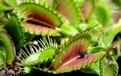  The Venus Flytrap is a carnivorous plant that catches and digests animals prey consisting mostly of insects and arachnids. The trapping structure is formed by the end of each plant’s leaves. The edges of a venus flytrap leaf are equipped with teeth-like protrusions while the insdie has red pigmentation that attracts insects.  The venus flytrap reveals the remarkable diversity in nautre – a carnivorous plant containing serveral traps that can snap shut in milliseconds to capture prey.  The plant is found in nitrogen-poor environments, such as bogs. The nutritional poverty of the soil is a reason for the plant to have such elaborate traps as an adaptation: insect prey provide the nitrogen for proetin formation that the soil cannot. | 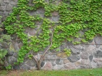  The Boston Ivy plant sercretes a sticy calcium carbonate, which serves as an adhesive pad and gives it the ability to attach itself to a wall without requiring any additional support, while it does not penetrate the building surface but merely attaches to it. Nevertheless, damage can oocur from attempting to rip the plant from the wall. However, if the plant is killed first, such as by severing the vine from the root, the adhesive pads will deventually deteriorate to the point where the plant can be easily removed without damage.
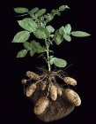  Potatoes contain toxic compoiunds known as glycoalkaloids, of which the most prevalent are solanine and chaconine. Solanine is also found in other plants in the family Solanaceae, which includes such plants as the deadly nightshade, henbane, and tobacco as well as the potatoe, eggplant and tomato. This toxin affects the nervous system, causing weakness and confusions. These compounds, which protect the plant from its predators, are, in general, concentrated in its leaves, stems, sprouts, and fruits. Exposure to light, physical damage and age increase toxin levels within the tuber. Cooking at high temperatures partly destroy these. The concentration of glycoalkaloids in wild potatoes suffices to produce toxic effects in humans. They cause headaches, diarrhea, cramps, and in severe cases coma and death; however, poisoning from potatoes is very rare. | The fruit serves as a mother’s womb where the embryo of a baby plant is nurtured. It protects the embryo or the seed. The flesh of the fruit serves as a protecitve lining as the seed develops. And, before the seed is ready to be sowed, the gruit is unripe and tastes sour. The sourness of the fruit discourages us from eating it.  Nature decided that gruits should become sweet only when they are ripe and the seeds ready to be sown on Earth. The ripe fruit tempts you to eat it. So that after you eat it and throw the seed on the ground, it germinates in the soil to bring about a new plant.

