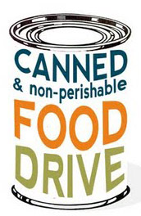**WHEN:** November 13th

through the 17th

**WHO:** Edsel Ford and all of our

feeder schools are competing

against Dearborn and Fordson

to see who can collect the

most cans for Gleaners!

WHY: Gleaners gives food to

families in need every

opportunity they get and we will be

supporting them in their efforts!



