First Grade School Supplies

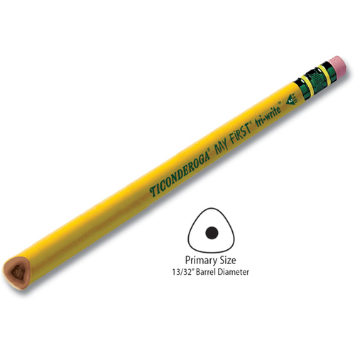

Here is the list of supplies that will be helpful to get our school year started off right!

**We share our supplies within our classroom community ☺**



* Primary (big) Pencils
* 1 pair Safety Scissors
* 2-3 large Elmer’s brand glue sticks
* 1 (24 count) box crayons
* 2 folders with pockets
* 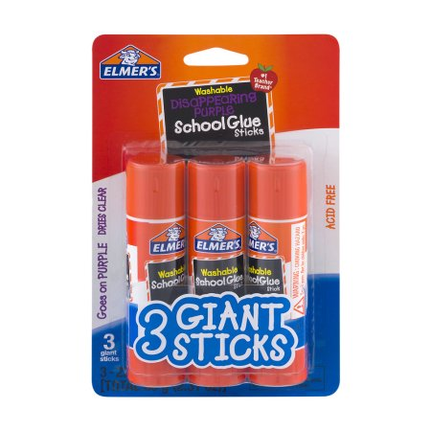2 boxes of Kleenex
* 1 bottle of hand sanitizer
* 2 packages of Clorox disinfectant wipes
* 1 bottles of Lysol disinfectant spray
* 2 rolls of paper towel

Thank you in advance for supplying our classroom with these necessities!

-Ms. Brown