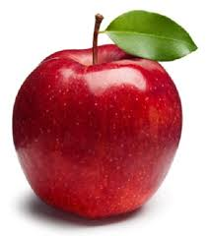Healthy Snack Suggestions:

Please don’t bring any snacks containing peanuts as we have students in our class that are allergic!

* 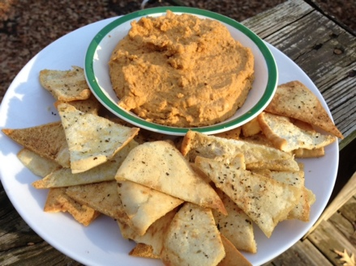fruits
  + bananas
  + cherry tomatoes
  + grapes
  + apples
  + pears
  + oranges
  + strawberries
* vegetables
  + cucumbers and dip
  + celery with cream cheese filling
  + carrots and hummus
* baked chips
* 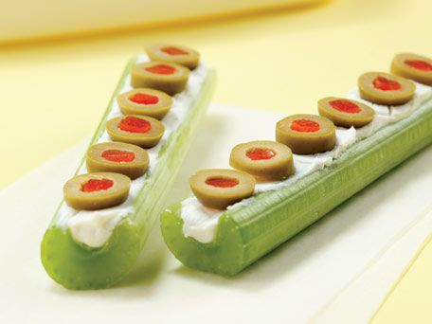pita chips
* yogurt
* string cheese
* pretzels
* raisins
* pumpkin seeds
* applesauce

These are just a few of the healthy options your child can bring! Please no cookies, pudding, cheetohs, etc. We are looking to make our brains grow and for that, we must eat healthy food.

