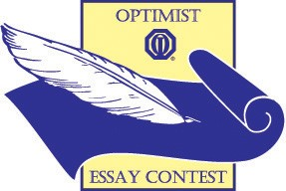

DEARBORN OPTIMIST CLUB

ESSAY CONTEST

Can Society Function Without Respect?

Deadline: Monday, January 8, 2018

1st Prize: $500.00
2nd Prize: $250.00
3rd Prize: $125.00

Go to dearbornoptimist.org for official application and rules
Contact Person: Mrs. Lori Divis
E-mail: divislori@gmail.com

