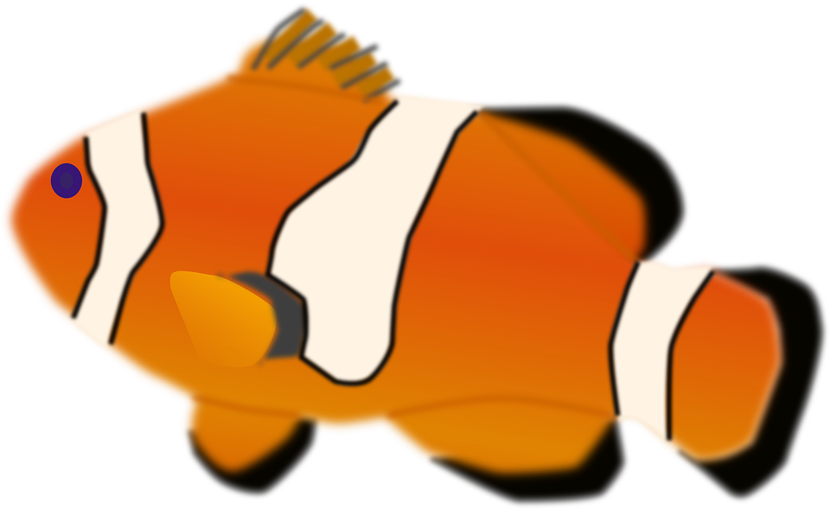March 2019
Sunday | Monday | Tuesday | Wednesday | Thursday | Friday | Saturday
 |  |  |  |  | .March is Reading Month Kick off  decorate classroom door  استقبال شهر القراءة-تزيين ابواب الصف | 2  Go to the public library  اذهب الى المكتبة العامة
3 Read with a family member  اقرأ مع احد افراد العائلة | 4 Read by flashlight  اقرأ على ضوء المصباح اليدوي | 5 List all the people you know that love to read. | 6  Math Problem in your pocket day. | 7  Write a story with your favorite character in it. | 8  Read a magazine | 9 Read a “Good Fit” book  اقرأ كتابا مناسب لك.
10  Run outside for 10 minutes.  اركض لمدة 10 دقائق | 11  Be a word day, Pin a word to the front, and put the definition on the back | 12  Read the cover of a cereal box.  Oakman spirit wear day! | 13 Write a joke, and put it in your pocket for school.  Dress like a sea Creature. | 14 Mismatch/crazy hair Day | 15  Pajama Day  Read In | 16  Go to the public library  اذهب الى المكتبة العامة
17  Read with a stuffed animal/  Spirit week!  اقرأ مع الحيوان اللعبة-اسبوع اللهو | 18  Read a non-fiction book  اقرأ كتابا علمي\غير خيالي | 19 Read a story and tell it to someone else  اقرأ قصة واخبرها لاحد ما. | 20  Draw a sea Creature, name it. and put it in your pocket | 21  Call a relative, and read them a short story.  اتصل باحد الاقرباء واقرا قصة صغيرة لهم. | 22  Turn off the TV and read tonight  اطفئ التلفاز واقرأ | 23  Take a walk with a family member and talk about your favorite book.  قم بالمشي مع احد افراد العائلة واخبرهم عن كتابك المفضل.
24 Read a cookbook.  Make a snack.  اقرأ كتابا للطبخ -حضر وجبة خفيفة | 25 Write a story with your favorite character in it.  اكتب قصة فيها احد الابطال المفضلين لديك. | 26 Write a letter to a friend and give it to them tomorrow at school. | 27  Write a poem and put it in your pocket. | 28 Read a book to your stuffed animal  اقرأ كتابا للحيوان اللعبة | 29  March is reading month wrap up! | 30

