**Spirit Week**

**(December 17-21)**

**Monday: Dress to Impress (Favorite dress, suits, tie, nice hair)**

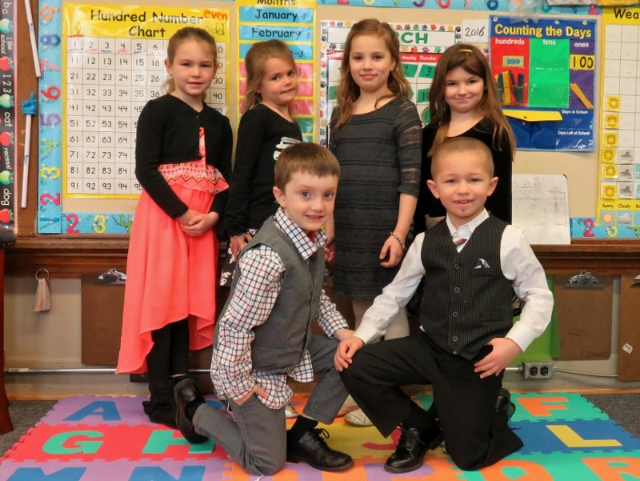

**Tuesday: Sports Day/Oakman Gear (Favorite jersey, Oakman shirt)**

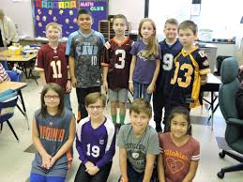

**Wednesday: Crazy Scientist Day (Crazy hair, wear older brother/dads button up shirt, white coat, safety glasses )**



**Thursday: Pajama Day**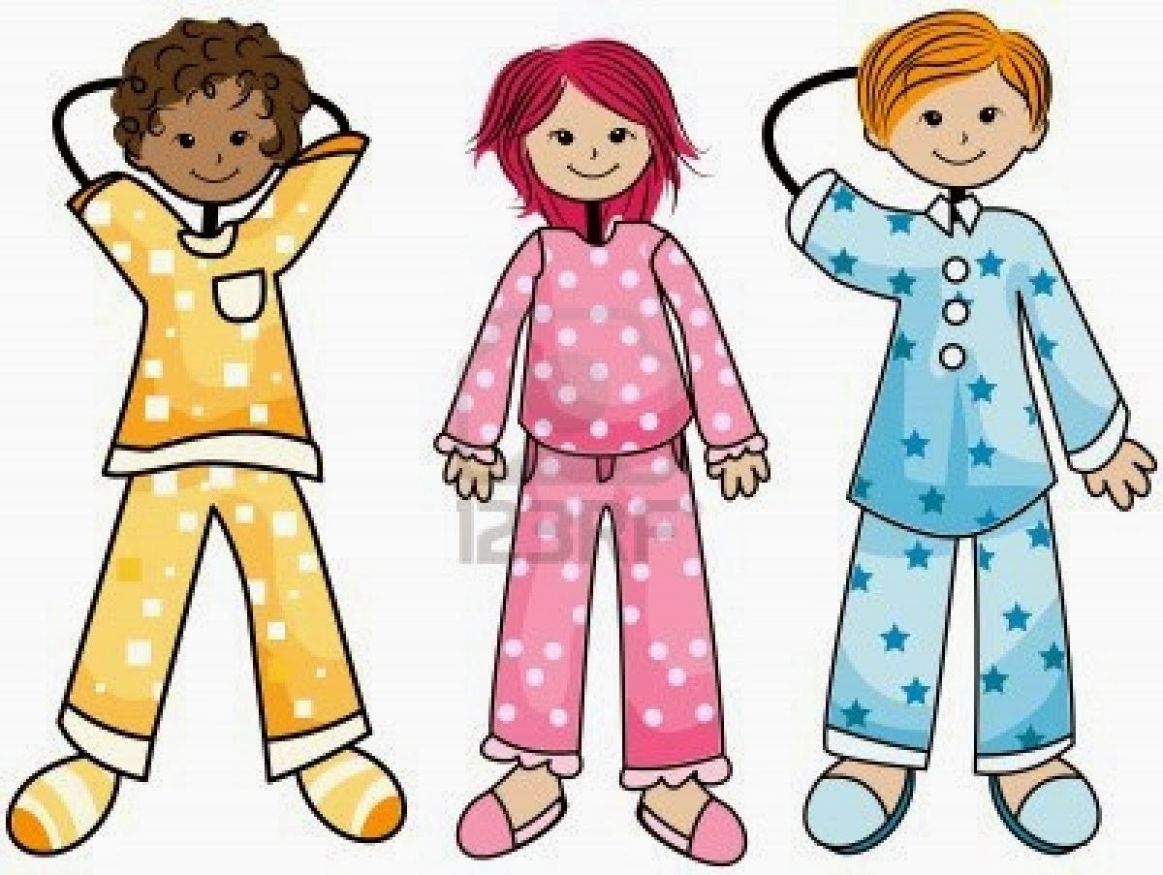

**Friday: Wear Holiday Colors (green & red, santa hat)**

