Dear Parent or Guardian,

During the 2019-2020 school year, your child’s social studies teacher will be participating in a professional development series sponsored by the University of Michigan, Ann Arbor, School of Education. This professional development seeks to improve middle school social studies teaching. This professional development is part of a research study funded by the James S. McDonnell Foundation that seeks to examine the impact of professional development on teaching practice.

As a part of this study, your child’s teacher will occasionally be video recording his/her classroom instruction in social studies. These recordings will be studied with a focus on teaching practice and on students’ thinking and talk about social studies. Also as a part of this study, your child’s teacher will be sharing your child’s written work with us during the year. This written work will be studied with a focus on teaching practice and on students’ thinking and writing. Our goal is to understand how professional development supports teachers’ learning and the influence of teachers’ learning on children’s learning.

Please be assured that your child’s confidentiality will be respected and maintained. Your child’s name and other identifying information will not be shared.

The videos and written work will be used by the research team to study the teaching in the classroom before and after the professional development and to report on this work in professional journals and other publications, on our website, as well as in presentations. We will not include any information in any published or presented materials that would identify your child. We will make sure that your child’s name or other identifying information is not in print materials that we share. It is possible, however, that someone who already knows your child may recognize them in a video segment. We will use video segments in developing resources to support high-quality professional development for social studies teachers and will share them on a website designed for other researchers, teacher educators, and teacher leaders working on teacher and student learning in social studies.

To keep this information safe while it is being studied, the video record of the classroom teaching will be uploaded to a secure electronic storage site. Researchers will enter study data on a computer that is password-protected. The researchers plan to destroy the classroom video footage following the completion of the study.

If you do NOT want your child’s image to be captured on the video recording or work to be collected as part of this study, please return the attached form to your child’s teacher.

If you have any questions or concerns about the research study, please feel free to contact Chauncey Monte-Sano, the principal investigator for the study at 734-647-4253. If you wish to obtain information, ask questions or discuss any concerns about this study with someone other than the researcher(s), please contact the University of Michigan Health Sciences and Behavioral Sciences Institutional Review Board at 866-936-0933 or via email at irbhsbs@umich.edu.

Sincerely,

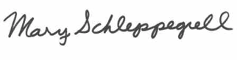

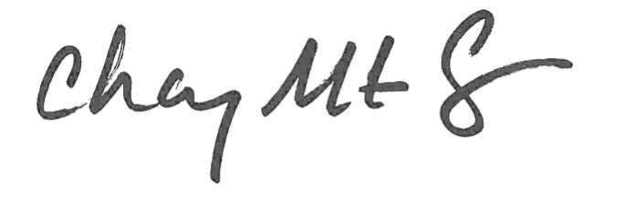

Chauncey Monte-Sano Mary Schleppegrell

[cmontesa@umich.edu](mailto:cmontesa@umich.edu) [mjschlep@umich.edu](mailto:mjschlep@umich.edu)

734-647-4253 734-647-2449

**Title of the Project:** *Teachers Learning to Facilitate Communication and Reasoning Through Inquiry with History and Social Science Sources*

**Principal Investigators:**

Chauncey Monte-Sano, PhD, University of Michigan

Mary Schleppegrell, PhD, University of Michigan

 ***I do NOT want my child’s image to be video recorded to be collected as a part of the study,*** *Teachers Learning to Facilitate Communication and Reasoning Through Inquiry with History and Social Science Sources*

 ***I do NOT want my child’s written work to be collected as a part of the study,*** *Teachers Learning to Facilitate Communication and Reasoning Through Inquiry with History and Social Science Sources*

____________________________________________

Child Name

_________________________________________________

Parent/Guardian Printed Name

_________________________________________________

Parent/Guardian Signature

_________________________________________________

Teacher/Grade

________________________________________________

Date