**Name:_____________________________________________________#:_____Date:____________________________**

**Chapter 24: Oil in the Southwest Asia: How Black Gold Has Shaped a Region Study Guide**

Label on this map these countries: **Saudi Arabia, Iraq, Iran, Kuwait, Syria, United Arab Emirates (UAE), Yemen, Jordan, Israel** and **Egypt**. Color them in different colors. These will be the ten countries you will need to know for your test.

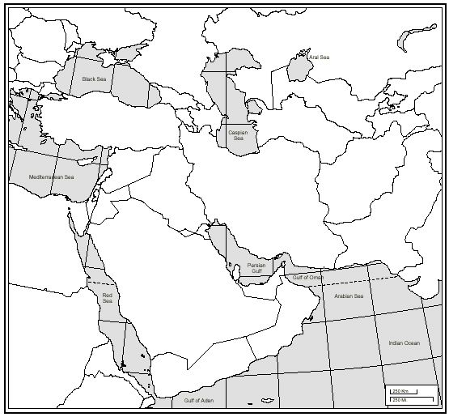

01. Who controls the world’s oil supply?

02. Approximately how much oil is left on Earth? When do experts believe it will run-out?

03. How might having a valuable natural resource such as oil affect a region such as the middle-east?

04. Define **state.**

05. What is so unique and special about Dubai?

06. A person who wanders from place to place is a what?

07. Define **desert.** What is the biggest desert in the middle-east?

08. What is oil that has been discovered but remains unused in the ground?

09. What two countries have the largest oil reserves as of 2013?

10. What is the difference between **proven** and **unproven reserves**?

11. Define **crude oil.**

12. What is the difference between **developed** and **developing** countries? Give examples.

13. What is the difference between **non-renewable resources** and **renewable resources**? Provide examples.

14. A group of people in a country who share a unique culture and identity is what?

15. What is the **Organization** **of the Petroleum Exporting Countries (OPEC)**?

16. A type of rock that does not allow liquid or gas to flow through it is called what?

17. What other things besides gasoline are made from oil? Name three.

18. Define **plate tectonics.**

19. What is the tectonic plate(s) are located in middle-east? When you live near tectonic plates what thing(s) do you have a higher chance of having?

20. Define **distribution** and why is there an issue of distribution of wealth in the middle-east?

21. What country has the highest life and lowest expectancy rates?

22. Define **per capita.**

23. The number of infant (babies), out of 1,000 babies born in a particular who die before age 1 is known as what? What kind of countries would have this be high?

24. Define **dictator.**

25. Who was Saddam Hussein? What did he do?

26. Why was Kuwait so important to Iraq and Saddam Hussein?

27. What is a **coalition**?

28. What are the capitals of these middle-eastern countries: Saudi Arabia, United Arab Emirates (UAE), Egypt, Lebanon, & Israel?

29. Explain the **Persian Gulf War**.

30. How is oil formed? (Page 360 in your text book can help you)