Chapter 2 Study Guide Answers.

**7 Thematic Maps**

**Physical Features map** – shows landforms, bodies of water and elevation

**Political Boundaries Map** – show international borders, locations of countries/capitals, and bodies of water

**Climate zones map** – shows the world’s 12 climate zone and location

**Vegetation Zones Map**- shows were different plants growing. In each zone a certain mix of plants have adapted to similar conditions.

**Population density** maps show patterns of where people live, number of people per square mile and the number of people in cities.

**Economic Activity Map s**hows how people make a living, land use, and location of natural resources.

**World Regions Maps** – divide the world into 7 large regions. Each region has certain distinct physical features and unique human features

1. The two states in the U.S. that are the highest provider for domestic oil are Texas and Alaska.

2. The four kinds of precipitation are rain, sleet, hail, and snow.

3. **Region i**s an area defined by one or more natural or cultural characteristics that set it apart from other areas.

4. **Weather** is the day to day conditions in the atmosphere, and **climate** is the pattern of weather over a long period of time.

5. The three most population countries in the world are

1. **China**

**2. India**

**3. United States**

**6. Saudi Arabia and Middle East** provides more than 50% of all the oil in the world.

7. In **Michigan we have mixed forest vegetation** which is deciduous and coniferous trees.

8. The 3 natural resources/fossil fuels are **oil, coal, natural** gas. **Uranium** is another underground energy resource.

9. **Export** is when a product or resource is sold to another country.

**Import** is when a product or resource comes into a country.

10. The 3 most populated cities in the United States are

1. **New York**

**2. Los Angeles**

**3. Chicago**

**11.**  the most **densely populated state is New Jersey** and the **least populated state is Alaska**

**12.** Here in the Midwest we have **humid continental climate** which is warm rainy summers and cool snowy winters

13. be able to read this chart.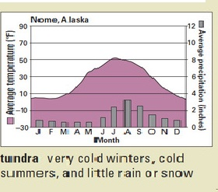

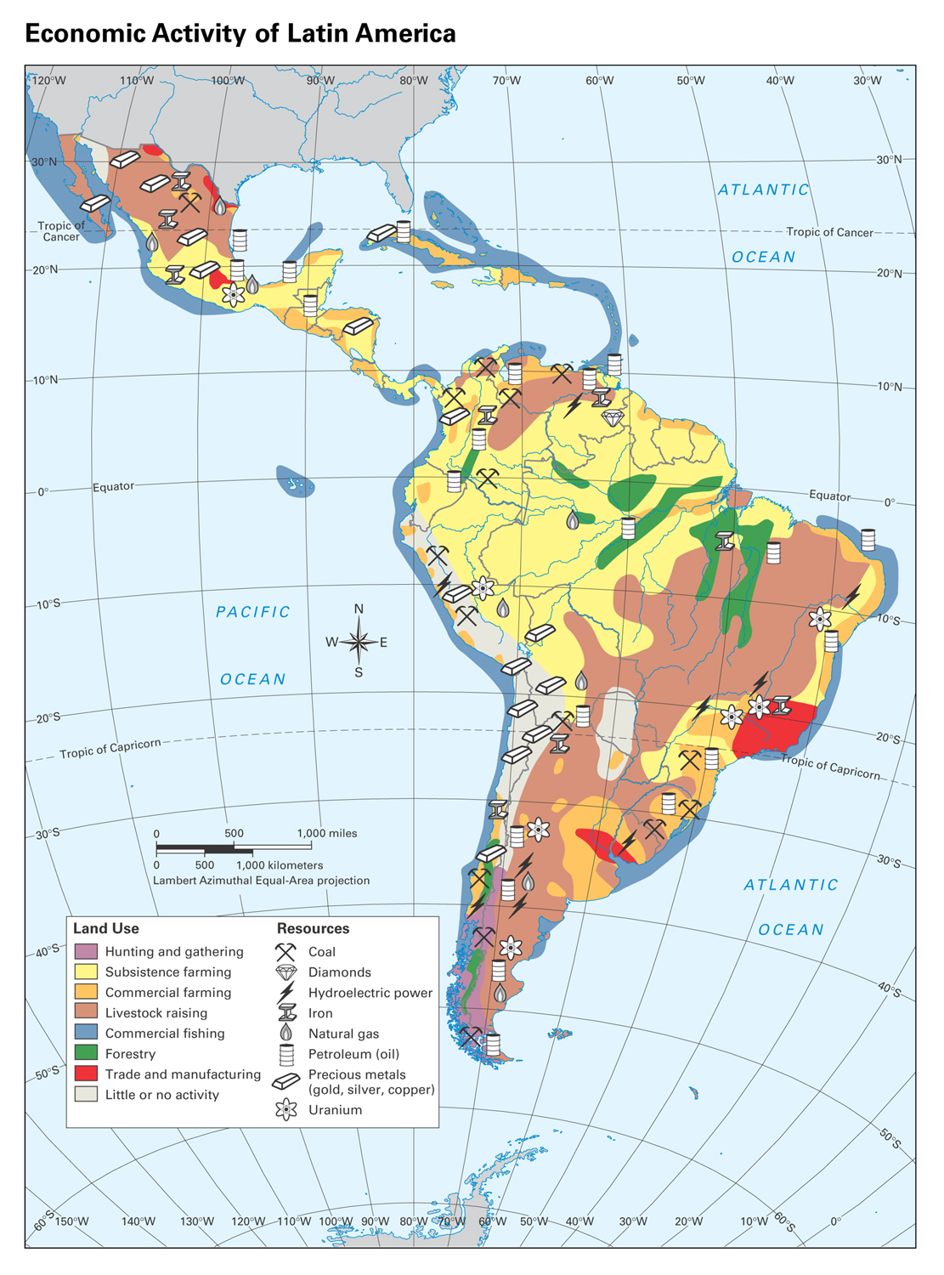

**14** In the thematic map above, what two things are feature on this map according to the key? How is most of the land in South America used? What resource does South America have the most of?

14. Answers: Land Use & Resources, Petroleum.

15. Know where low, middle, and high latitude. Note the locations of high, middle, low latitude (color coded) above and below the equator.

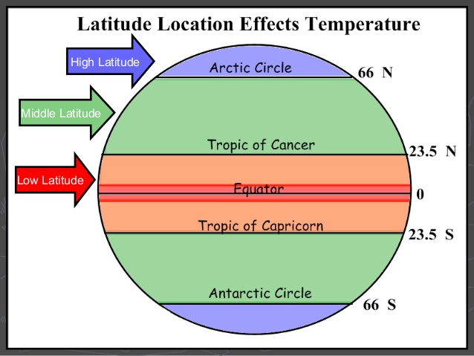

16. be able to identify lakes, isthmus, strait, archipelago, volcano, plateau, deserts, volcano and tributary.

17. 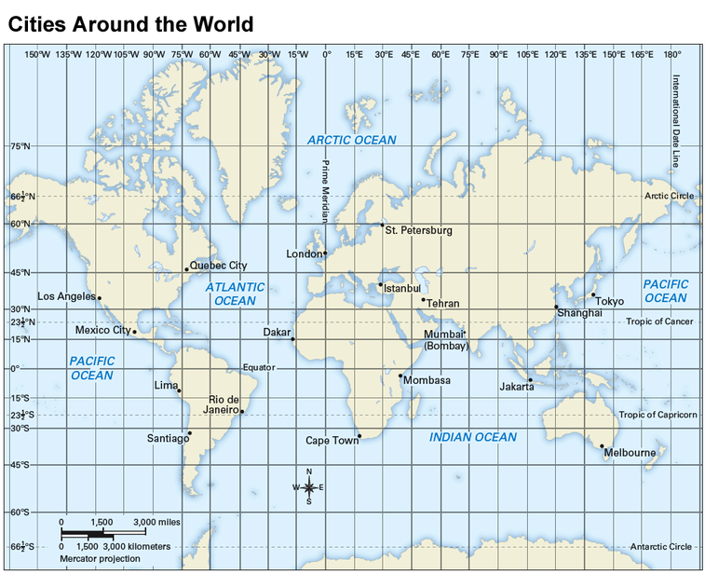

17. **Tropical Zone** (between 23.5°N and 23.5°S) **cities:** Mexico City, Dakar, Mumbai, Lima, Rio de Janeiro, Mombasa, and Jakarta.

49°N, 0° is **London**

60°N, 30° E is St. Petersburg.

18. Clearing the rainforest is an example of **HEI.**

19. **Population density** is the average amount of people per square mile; amount of people in an area.

20. **Elevation** is the height above sea level.

21. **Desertification** – the process by which land becomes more and drier until it turns into desert. This is caused by climate change and human activity.

22. **Forestry** – planting, growing, and harvesting trees.

23. **Region-** what areas have in common?

. 

24. Know the 5 important lines of latitude. See above.

25. The physical feature that most challenges the people of Europe are the many mountain ranges throughout Europe.

26. Most of Northern Africa has a low population density because of the Sahara Desert.

27. Michigan is in the Great Lakes Region because the geographic features of the Great Lakes (HOMES) border Michigan.

28. Cartographer is a person who draws or produces maps.

29. 460 N. Vernon is example of **absolute location** of Bryant.

30. The 4 kinds of precipitation are snow, rain, sleet, hail.

31. Primary Resources - First-hand account of an event, taken at the time and place of the occurrence: speeches, diaries, interviews, photographs, autobiography, artwork.

32. Secondary Resource – is a second hand account, it analyzes and interprets primary sources: magazine articles, textbooks, biography, editorials.

33. The problem with maps is distortion a change in the shape or size.

34. The main cause of major earthquakes is the movement of tectonic plates.

35. The Ring of fire marks volcanic activity around edge of which ocean Pacific.

**36.** Know the physical features that located within the Tropical Zones. See your own Earth’s Physical Feature Map we created in class.