**The World In Spatial Terms -UNIT 2 STUDY GUIDE**

*Write the answers to the questions below in complete sentences. The answers can be found in your Global Studies Binder and ISN.*

1. Define Geography-

2. Define physical geography and list 4 examples.

3. Define spatial scales and give the 4 levels of spatial scales

4. Define map. What is the problem with maps?

5. What is distortion?

6. Draw, color , and label an isthmus, strait, archipelago, tributary below. Also be able to identify a volcano, plateau, lakes , & deserts.

8. Define cartographer and explain the big challenge cartographers have.

9. Define thematic maps and list 6 different types of thematic maps found in your text book. Explain what features are displayed on each of these maps.

10. Draw a large circle and label the 5 lines of latitude that affect climate. Color and label the climate zones inside these lines of latitude below.

11. Know what parts of the world and physical features are found in the tropical zone.

12. Explain which physical feature most challenges the people of Europe.

13.Why does most of the northern area of Africa have a low population density.

14.What places Michigan into the Great Lakes Region?

15. Know how to use the global grid. List all the cities in the tropical zone. What city is at 49°N, 0°? Write the coordinates for St. Petersburg.

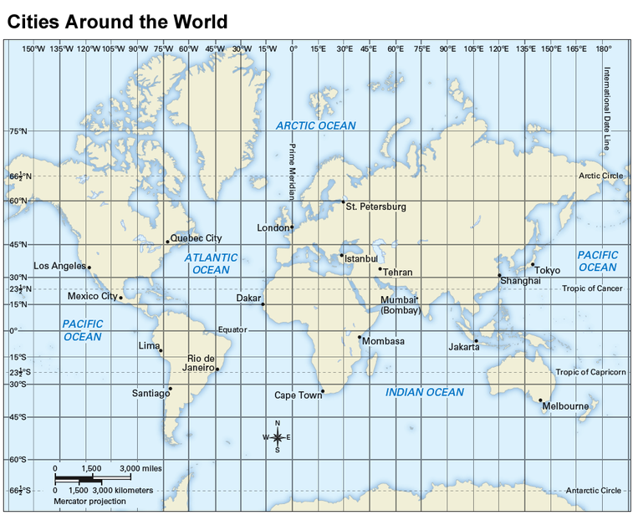

16. Clearing the rainforest is an example of which of the 5 themes?

17. Define population density.

18. What are natural resources? Give examples

19. Define economic activity,

20. Define elevation

21. What are natural and physical processes?

22. Explain 4 physical processes from chp. 17. See Thursday’s bldg.

23. Define regions

24. Know the 5 themes and examples for each.

25. Know how to read the thematic maps and other charts and graphs.

26. Four kinds of precipitation