**Name:________________________________________#:____Date:________________________________**

**Chapter 5: “Urban Sprawl in North America: Where Will it End?” Study Guide Answers**

01. A developed area at the edge of a city that is mainly homes is called what? What would also be an example? Suburb; Dearborn is an example of a suburb

02. Define **urban sprawl**.

The rapid often poorly planned spread of development from an urban area outward into rural areas.

03. Fill-in the correct terms **(urban core, urban fringe & rural fringe)** in the graphic organizer below.

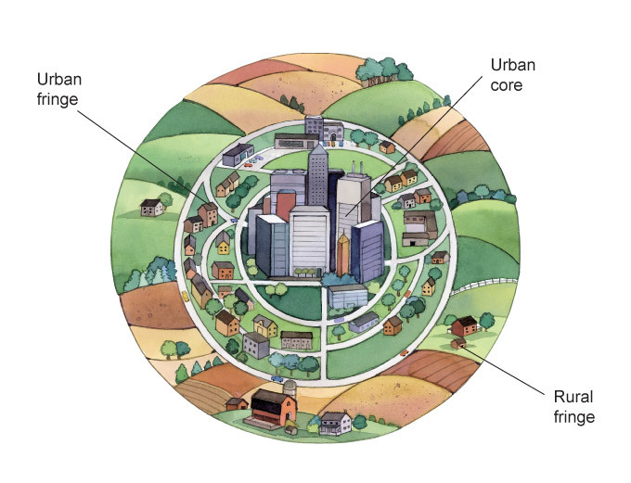

04. **True or False:** Major cities that have urban sprawl tend to grow or spread **inward**.

False; urban sprawl spread outward.

05. A major population center made up of a large city and the smaller suburbs and towns that surround it is called a what? Metropolitan Area What would also be an example? Detroit,

Los Angeles, New York, Toronto, and Atlanta

06. Define **urban core**.

The older part of a big city; often the urban core servs as the downtown or central business district of a city .

07. The ring of a small towns and suburbs that surround a big city is known as what? Dearborn, Southfield, Hazel Park, Melvindale and Grosse Point are examples.

a.) urban core b.) urban fringe

c.) rural fringe d.) metropolitan area

08. **True or False:** The small towns, farms and open spaces that lie just beyond a city’s suburbs and connected to cities by roads and highways is known as the **rural fringe**.

TRUE

09. A majority of the population in the United States live near what?

Urban Areas

10. Define **habitat**.

The natural environment in which a plant or animal lives.

11. Damage to the natural environment caused by harmful substances is known as what?

a.) The Clean Air Act b.) GNP (Gross National Product)

c.) pollution d.) fossil fuels

12. What is the difference between **rural** and **urban**?

Relating to or locating in the city- Urban

Relating to country or farming Rural

13. The ways in which people use a particular area of the Earth’s surface; for example, for farming, development or preservation is known as what? Land use

14. **True or False:** The **Clean Air Act** is a U.S. federal law designed to control air pollution on a national level.TRUE

15. What are **three advantages** of urban sprawl?

Land & building cost cheaper

Houses then are more affordable

Suburbs a better place to raise families

More construction jobs

Helps local business

Taxes help fund roads & schools& other services

16. What are **three disadvantages** of urban sprawl?

Damages the environment

Destroys animal habitat

Lose trees & vegetation

Increase use of cars= more pollution

Taxes go up because of ongoing development

17. What U.S. city was the first state to create a set of land-use planning laws?

a.) Atlanta b.) Phoenix

c.) Portland d.) Toronto

18. Define **urban growth boundary**.

A legal border that separates an area where development is permitted from an area where development is forbidden

19. A network of buses, trains and other vehicles used for moving passengers throughout a city is called what? Public Transit System

20. **True or False:** Mixed-use development combines housing and businesses in **multiple** areas.

FALSE : Combines the two in ONE area

21. Define **infill**.

Filling in empty and run-down parts of the city with new developments

22. What are the **three** things that decrease along with urban sprawl when there is a public transits system? Traffic jams, air pollution, & poorly planned development

23. **True or False:** Developers building an apartment high-rise or shopping mall on an empty lot is an example of **infill**. TRUE

24. In 1973, Oregon placed growth boundaries around its urban areas. What was the main

purpose of these boundaries? Stop development of farmland

25. Toronto’s Official Plan encourages infill instead of urban sprawl. Which of these is the best example of infill? Replace abandon factory with new apartments

26. Urban sprawl looks different in different parts of the world because of what two things?

Population & Money: Poor countries have little control over how their cities grow. Whereas

Wealth regions tend to have more large cities & are more developed.

27. Experts believe by the year 2025 the total urban population will be **(less or more)** than that of the rural population. More than that of rural.

28. Define **smart growth**.

Land use planning that controls urban sprawl making better use of land that has already been developed

29. The number of people who live in a specified area is called what? Population

30. **True or False:** Developers that build upward **do not** help the urban sprawl issue within major cities. FALSE

31. What are the **three most populated** cities in the United States?

New York, NY

Los Angeles, CA

Chicago, IL

32. **True or False:** Between 1982 and 1997 the U.S. lost almost 7 million acres of farmland.

TRUE

33. What continent has more people than any other continent?

ASIA

34. **True or False:** Wealthy regions tend to have **less** large cities than poor ones.

Wealthy city have more large cities than poor ones

35. Why do you think urban sprawl is a hot issue and a worldwide problem? Give two reasons.

Many think they should do more to control urban sprawl. They also think people who want to buy houses on the rural fringe should be able to do so

36 Atlanta has been called “the fastest-spreading human settlement in history.” Where has most of this settlement taken place since the 1990s?

Settling on the rural fringe