**Name:________________________________________#:____Date:________________________________**

**Chapter 5: “Urban Sprawl in North America: Where Will it End?” Study Guide**

01. A developed area at the edge of a city that is mainly homes is called what? What would also be an example?

02. Define **urban sprawl**.

03. Fill-in the correct terms **(urban core, urban fringe & rural fringe)** in the graphic organizer below.

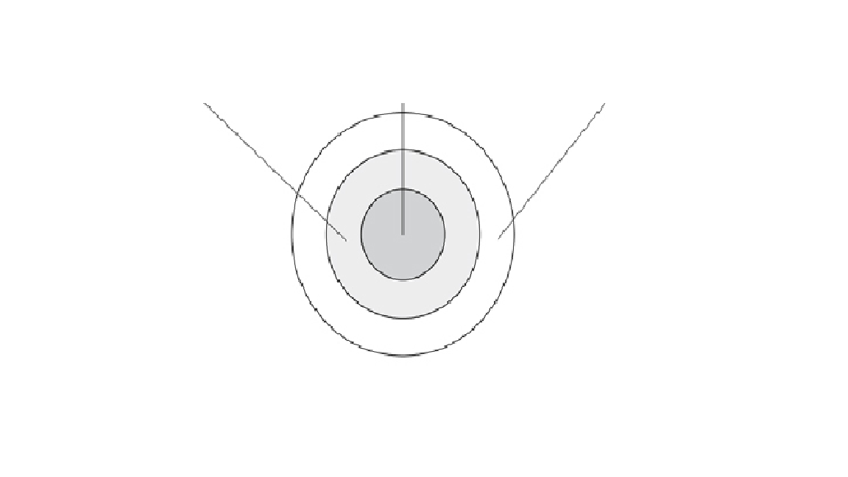

04. **True or False:** Major cities that have urban sprawl tend to grow or spread **inward**.

05. A major population center made up of a large city and the smaller suburbs and towns that surround it is called a what? What would also be an example?

06. Define **urban core**.

07. The ring of a small towns and suburbs that surround a big city is known as what? Dearborn, Southfield, Hazel Park, Melvindale and Grosse Point are examples.

a.) urban core b.) urban fringe

c.) rural fringe d.) metropolitan area

08. **True or False:** The small towns, farms and open spaces that lie just beyond a city’s suburbs and connected to cities by roads and highways is known as the **rural fringe**.

09. A majority of the population in the United States live near what?

10. Define **habitat**.

11. Damage to the natural environment caused by harmful substances is known as what?

a.) The Clean Air Act b.) GNP (Gross National Product)

c.) pollution d.) fossil fuels

12. What is the difference between **rural** and **urban**?

13. The ways in which people use a particular area of the Earth’s surface; for example, for farming, development or preservation is known as what?

14. **True or False:** The **Clean Air Act** is a U.S. federal law designed to control air pollution on a national level.

15. What are **three advantages** of urban sprawl?

16. What are **three disadvantages** of urban sprawl?

17. What U.S. city was the first state to create a set of land-use planning laws?

a.) Atlanta b.) Phoenix

c.) Portland d.) Toronto

18. Define **urban growth boundary**.

19. A network of buses, trains and other vehicles used for moving passengers throughout a city is called what?

20. **True or False:** Mixed-use development combines housing and businesses in **multiple** areas.

21. Define **infill**.

22. What are the **three** things that decrease along with urban sprawl when there is a public transits system?

23. **True or False:** Developers building an apartment high-rise or shopping mall on an empty lot is an example of **infill**.

26. Urban sprawl looks different in different parts of the world because of what two things?

27. Experts believe by the year 2025 the total urban population will be **(less or more)** than that of the rural population.

28. Define **smart growth**.

29. The number of people who live in a specified area is called what?

30. **True or False:** Developers that build upward **do not** help the urban sprawl issue within major cities.

31. What are the **three most populated** cities in the United States?

32. **True or False:** Between 1982 and 1997 the U.S. lost almost 7 million acres of farmland.

33. What continent has more people than any other continent?

34. **True or False:** Wealthy regions tend to have **less** large cities than poor ones.

35. Why do you think urban sprawl is a hot issue and a worldwide problem? Give two reasons.