**Chapter 32 Study Guide**

Know the 9 terms. Know how to read and interpret Choropleth Maps, Pie charts, and line graphs like this: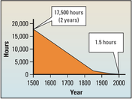

Answer the questions below in a complete sentence.

1. Globalization has led to the rapid increase of _____________.

2. According to the graph above how many hours did it take to sail by ship around the world in 1500?______

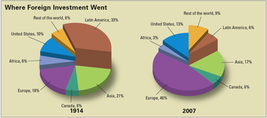

3. Which region of the world received the most foreign investment in 1914?

4. Which region of the world more thn doubled its percentage of foreign investment between 1914 and 2007?

4. What term means a business that has operations all over the world?

5. Why does material for producing sneakers come from all over the world?

6. Name the country that is a major center in sneaker design?

7. If a foreign company ships its product to the U.S. without paying taxes, this is an example of ________?

8. _________is a country that is a major producer of synthetic rubber.

9. List the factors that contribute to globalization.

10. Give a real world example of economic interdependence.

11. What are the 3 parts of a sneaker?

12. Why are Texas and Venezula places that provide material for the upper?

13. What are the two reasons that companies have moved their production to Asia?

14. What are sneakers made of?

15. Where does natural rubber come from? What is used to make synthetic rubber?