**Chapter 32 Study Guide**

Know the 9 terms. Know how to read and interpret Choropleth Maps, Pie charts, and line graphs like this: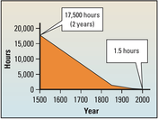

Answer the questions below in a complete sentence.

1. Globalization has led to the rapid increase of international trade.

2. According to the graph above how many hours did it take to sail by ship around the world in 1500?17,500

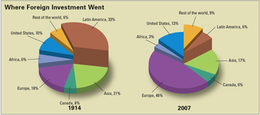

3. Which region of the world received the most foreign investment in 1914?

Latin America

4. Which region of the world more than doubled its percentage of foreign investment between 1914 and 2007?Europe

5. What term means a business that has operations all over the world?multinational corporation

6. Why does material for producing sneakers come from all over the world?

Because countries rely on one another for resources, technology, and trade

7. Name the country that is a major center in sneaker design?United States

8. If a foreign company ships its product to the U.S. without paying taxes, this is an example of free trade?

9.This is a country that is a major producer of synthetic rubber.Taiwan

10. List the factors that contribute to globalization. Advances in communication/transportation, free trade, rise of multinational corporations, and economic interdependence.

11. Give a real world example of economic interdependence.China produces a large percentage of products sold in U.S.

12. What are the 3 parts of a sneaker? Upper, midsole, tread

13. Why are Texas and Venezula places that provide material for the upper?

Uppers are sometimes made of leather which comes from cowhide. Livestock centers

14. What are the two reasons that companies have moved their production to Asia?Companies moved to spend less on labor and materials. They could then sell the sneaker for less and still make a profit.

15. What are sneakers made of?cotton or leather

16. Where does natural rubber come from? What is used to make synthetic rubber?Natural rubber comes from the sap of rubber trees found in tropical countries.

Synthetic rubber is made from coal and oil.