Section 1
Africa Before European Domination pg. 773-774
True or False  - There were many languages spoken in Africa before European colonization. ___________  - Africa consisted of small villages and large empires. ___________  - Many converted to Islam or christianity. _______________  Interesting Fact  How long were Africans able to keep Europeans out of their continent?  ________________________________  Infer:How were they able to do this?  _________________________________  Setback and later inventions  What stopped Europeans from entering Africa? Why were they able to later enter Africa?______________________________  __________________________________________________  __________________________________________________  Connect it to Today: What allows us to navigate areas that are unknown to us? ____________________________________  _________________________________________________ | Literature and News Media  How did people learn about the continent of Africa before Europeans colonized it? ___________________________________________________  ____________________________________________________  Define: missionary ___________________________________  What is the irony behind the relationship between the goals of an explorer, missionary, humanitarian, and later colonizers of Africa? How did colonizers use these findings as a backbone for their mission? ________________________________________________________________________________________________________________________________________________________________________________________________________________  Illustrate the story behind these two men.  Missing: David Livingstone Found by: Henry Stanley

Stanley's Exploration of the Congo pg. 774
Explorer Stanley traces the Congo River.  List one detail from the book about his trip. | Put theses events in order. 1, 2, 3  Treaties are signed  King Leopold of Belgium gains control  King Leopold commissions Stanley's Exploration
Why did King Leopold want African land?  Reason 1- Above the surface (lie) Reason 2- Under the surface (truth) | - What was the result of the king’s abuse?  - Why was France upset at the King?  - What other countries had dibs on Africa?

Forces Driving Africa pg. 774-775 | The Division of Africa pg. 775-776
European Superiority Promoting Factors  True or False: National pride lead to colonization. What theory did Charles Darwin achieve?_______________________________________________________ Why did Europeans think Africans were on a “lower scale”?______________________________________________________________________________ How would Europe later use the products they manufactured from the natural resources they dug out from Africa? ________________________________________________________________________________________________ List the 4 factors that allowed Europeans to colonize Africa Factor 1 Factor 2 Factor 3 Factor 4 | Draw and list all answers on the outline below.  - Draw and label the discoveries in the south  - Label the big nations dividing the land.  - Give an appropriate title based on the context of inferiority, uncivility, and racism.  - Label the belgian congo and draw the resources extracted from their. Also include visuals of cash-crops.  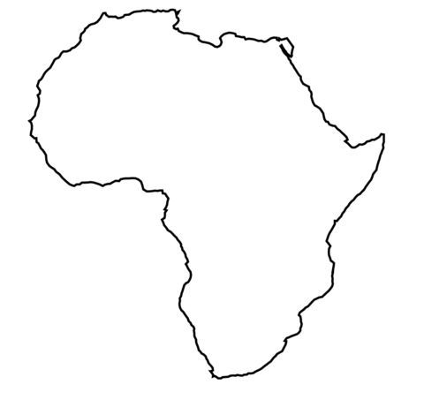

Three Groups Clash over South Africa pgs. 776-777
The Zulus  Who is Shaka?______________________  List one of his achievements:________________________________________________________  What tribe did he lead?_______________  How did they fight back against the British?  __________________________________  Which battle cost them their kingdom?  _____________________________ | Boers  - Label each picture with one of the following titles: Cape of Good Hope, Great Trek (journey), The Dutch  - Provide 1 detail from the book about each. | The Boer War  Classify the causes and effects of this war.  - South Africans took part in the war  - Diamonds and gold discovered  - 14,000 South Africans died  - Boers blamed the British  - British burned farms  - British won war  - Imprisoned women and children  Causes  Effects

