WHaG **Thomas Hobbes vs. John Locke** Name:



**Thomas Hobbes** [Not the cartoon tiger, the other Hobbes]

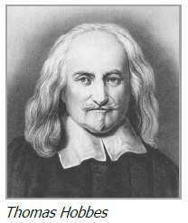 Thomas Hobbes was an English scholar and philosopher. He was born in 1588 and later became a tutor to a very wealthy family. As a tutor Hobbes had access to many books, traveled often, and met many important thinkers. Hobbes lived in Paris through the **English Civil War** and was interested in the nature of government. He wrote about many topics, including politics, geometry, physics, religion, and history. Hobbes was one of many scholars who tried to answer the question, “Why do we have government?”

Hobbes saw humans as naturally selfish and quick to fight. He believed that before there were governments, people lived in a **state of nature.** In a state of nature, everyone had a right to everything. In order to get what they wanted, people would always be at war with everyone else. Nobody would produce anything like inventions, art, or even crops or tools because they would be afraid other people would take them away. Hobbes didn’t paint a very pretty picture of life without government.

1. How do you think living through the **English Civil War** affected Hobbes’ view of government and people?

2. According to Hobbes, what was a disadvantage (or two) of living in a **state of nature**?

Hobbes lived at a time when many philosophers were thinking about the nature of government. He was one of the first of his era to discuss the idea of a **social contract** between people and their government. A contract is an agreement in which both sides agree to something in order to reach a shared goal. In Hobbes’ view, people agreed to give up some rights and power in exchange for protection. But for Hobbes, the social contract was no two-way street. He believed that once the people agreed to hand over power in exchange for protection, they lost the right to overthrow, replace, or even question the government.

3. According to Hobbes, what rights did people give up for protection?

Hobbes wrote a book called Leviathan (luh-VI-uh-then) to explain how he thought governments should work. Hobbes wrote *Leviathan* during the English Civil War [A **leviathan** is a massive mythical creature with the form of a sea monster]. He wrote about the social contract, and he spent much of the book trying to show that a strong central authority was the only way to avoid the evils of war. Hobbes believed a single **sovereign**, or ruler, should have total authority over the people. He believed in a monarchy led by a king. That’s because he thought that government would work best if all the power rested in one place. No three branches for Hobbes!

Many political thinkers—including America’s Founding Fathers—built on Hobbes’ ideas, especially the idea of a social contract. Hobbes was more concerned with protection and order than rights. But people like John Locke and Jean-Jacques Rousseau changed the focus from monarchy to democracy—power with the people instead of a sovereign. They began to see that people have rights that must be protected even from government.

4. Who do you think represents the “leviathan” of Hobbes book? Explain

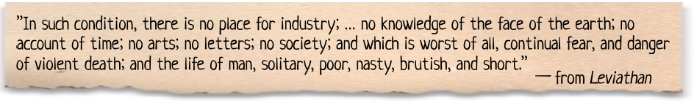

5. **Read** the excerpt from Hobbes’ book *Leviathan* (above) and think about what you have already learned about Hobbes. Then **check the correct boxes** for each condition below describing life with and without government.

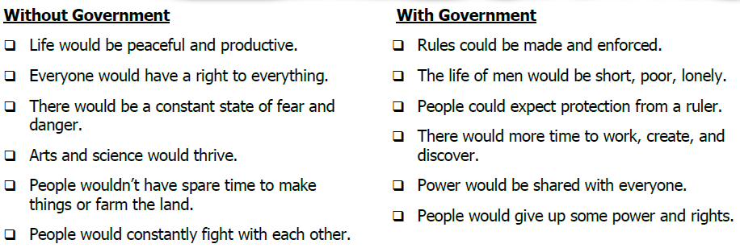

Sometimes you can judge a book by its cover. Look at a portion of the title page from *Leviathan* and answer the questions below. (Look closely, the big guy in the middle is made up of people!)

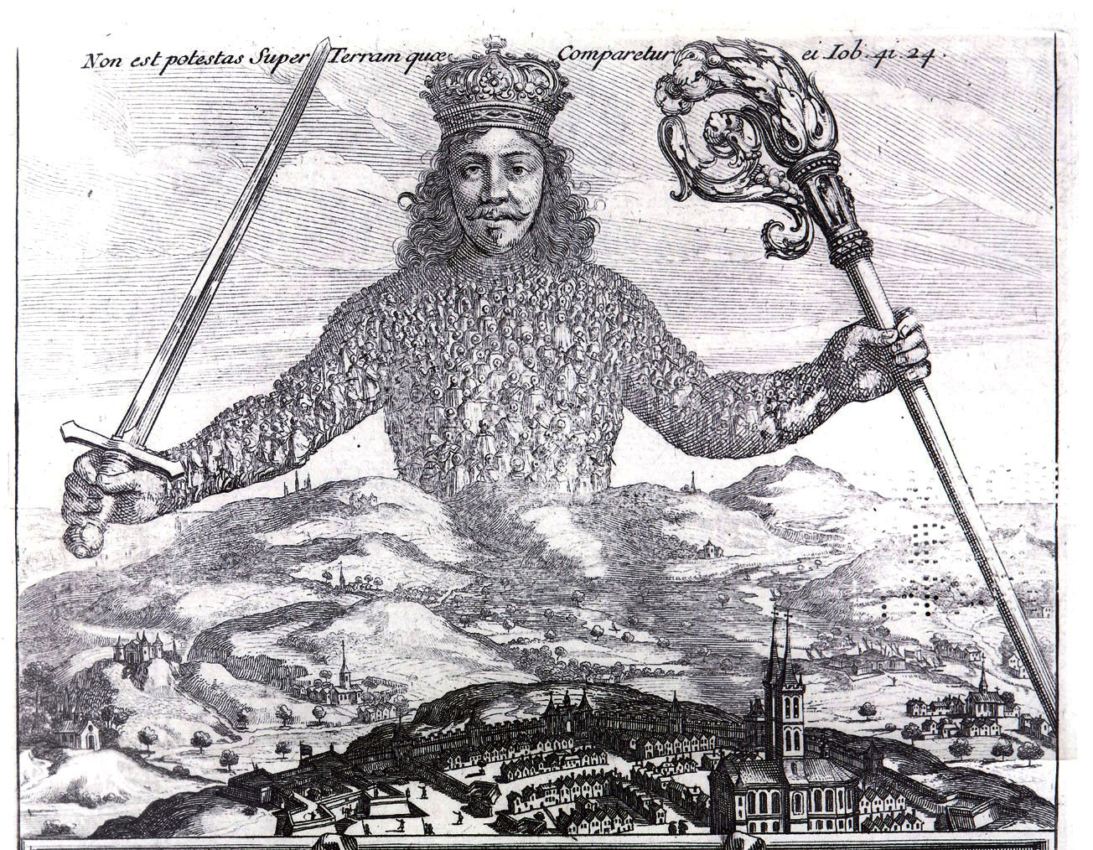

6. Draw a **circle** around the item in the illustration that represents the **monarchy**.

7. Draw a **rectangle** around the items in the illustration that represents **power**.

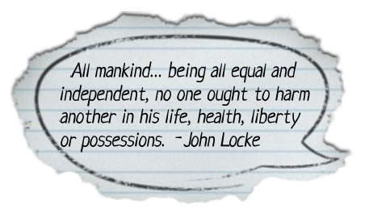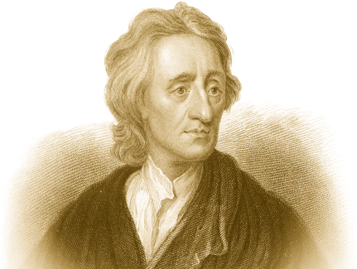**John Locke**

John Locke was born in England in 1632. Locke considered becoming a minister, started his career as a doctor, but ended up as a philosopher and political scientist. He had many interests and produced a number of writings that influenced future leaders. One of those leaders was Thomas Jefferson, who helped America gain independence from Britain nearly 150 years after Locke was born. Jefferson studied Locke’s writings, and Locke’s ideas show up in our own Constitution.

One of Locke’s books, called *An Essay Concerning Human Understanding*, took over 18 years to write! In it, he says that people are born with a mind like a **tabula rasa**, which means a blank slate or page. During life, that blank slate gets filled up with the things a person experiences with the five senses. He said people learn and develop differently because they are exposed to different things. The one thing people have in common is that they are human and share a human nature that is the same for all people everywhere.

8. What did Locke mean by saying that people are born with a mind like a **tabula rasa**?

Locke imagined a set of **natural rights** that human beings share. These are the right to life, liberty, and property. **Life** refers to the fact that people want to live and will fight to survive. **Liberty** means that people want to be as free as possible to make their own decisions. **Property** represents the fact that people want to own things that help them survive, such as land, food, and tools. Locke believed these rights aren’t given to people—people are born with them.

9. According to Locke, how did people get their **natural rights**?

Locke also wondered what life would be like if people didn’t have a government. In this **state of nature** there would be no rules, no one in charge, and no way for people to protect their natural rights. He believed the purpose of government is to end the state of nature and give people certain protections. Most importantly, Locke believed governments should protect people’s natural rights.

10. According to Locke, what was the purpose of government?

Locke believed a government can only be legitimate, or valid, if it is based on a social contract with citizens. A contract is an agreement between people in which both sides agree to something in order to reach a shared goal. A **social contract** happens between a government and its people. The people agree to give up some freedoms if the government agrees to protect everyone’s rights. If the government fails to deliver, the people revolt—like the colonists did during the American Revolution.

11. What did Locke believe would (and should) happen when a government did not protect people’s rights?

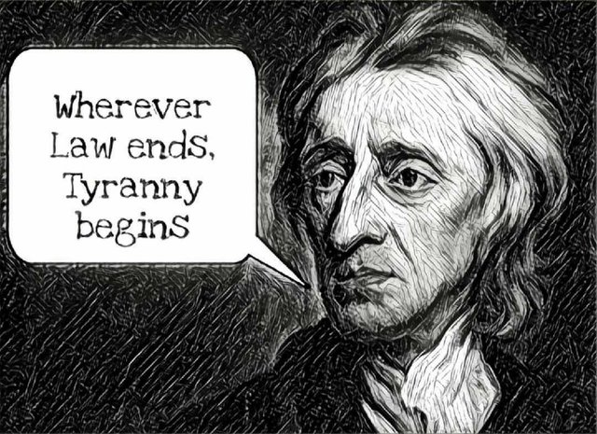

12. Complete the **crossword puzzle** using terms you learned in this reading on Locke.

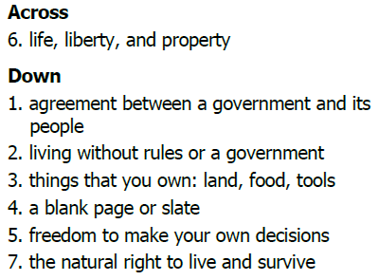

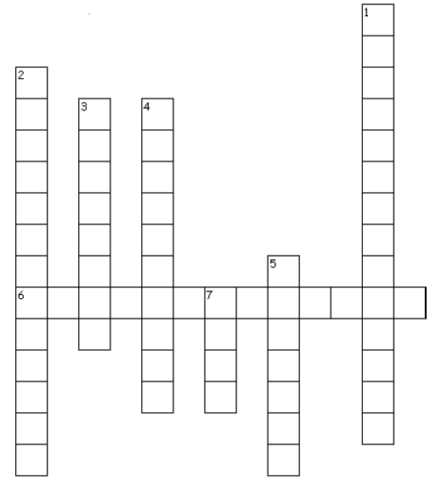

**Hobbes vs. Locke:** Circle the answer

13. Who was more concerned with **protection** and order rather than rights? Hobbes Locke

14. Who was more concerned with **people’s rights** rather than protection? Hobbes Locke

15. Who believed that the government and the people should have **social contract**? Hobbes Locke