WHaG **Enlightenment Thinkers: Rousseau + Montesquieu** Name:

**Jean- Jacques Rousseau**

Jean-Jacques Rousseau was born in Geneva, Switzerland in 1712. At age 30 he moved to Paris to become a musician and composer. However he is better known for his writings on human behavior and government. Rousseau believed that a government’s purpose is to protect liberty, or freedom, and to help people get along. Rousseau believed that the best form of government was a democracy. His writings influenced how people think about government and how a democracy should work.

What does freedom mean to you? Rousseau talked about two different types of freedom. **Natural freedom** happens when people live in a state of nature. In a state of nature there are no rules or governments. People are free to follow their instincts and selfish desires without considering the needs of others. But in a state of nature, people are not secure. **Social freedom** happens when people sacrifice some natural freedoms so they can have the freedom that comes with security and protection. To accomplish this, they establish rules and set up governments.

1. According to Rousseau, how was **Natural Freedom** different from **Social Freedom**?

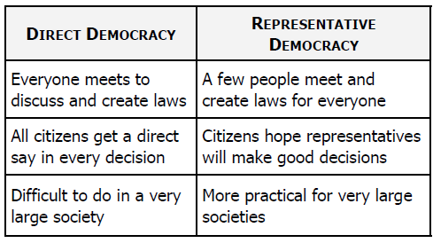

In his book The Social Contract, written in 1762, Rousseau talks about what makes an effective government. In order to have real authority, government must be based on an agreement, or contract, people make with society. People agree to give up some natural freedoms in exchange for protection. The government then follows the **general will**—those things that are in the best interest of society as a whole. If people disagree about what’s best, the government follows **majority rule**, or what more than half the people want.

There are two main types of democracies. In a **representative democracy**, citizens vote for a small number of people to represent the public in government. Only the representatives are directly involved in the government. In a **direct democracy**, all citizens are directly involved in making laws and running the government. This was the kind of participation Rousseau believed citizens should have, so he was in favor of direct democracy.

Rousseau’s work inspired many to think about the kind of government they wanted. This included the Founding Fathers of the United States, who wrote the United States Constitution. The Constitution created a democracy and guaranteed citizens a voice in government. Rousseau’s ideas can also be seen in one of Abraham Lincoln’s famous quotes, “a government of the people, by the people, for the people.”

2. Which **type** of democracy was Rousseau in favor of?

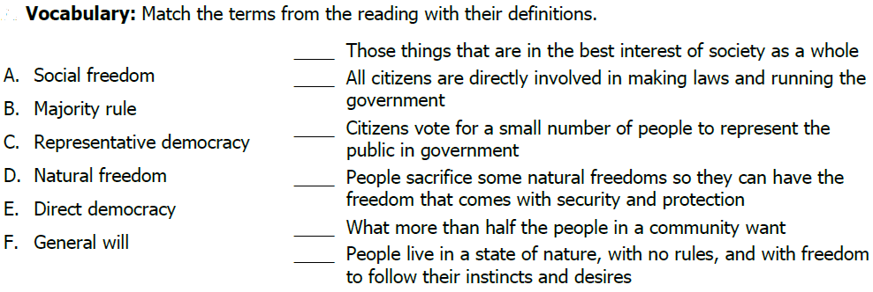

3.

**Baron de Montesquieu**

Charles Louis de Secondat was born in 1689 in the city of Bordeaux, France. At age 27, he became Baron de Montesquieu (MON-teh-skew) when he inherited his uncle’s fortune and title. Montesquieu was one of the great thinkers of the 17th and 18th centuries. He spent a lot of time thinking about how governments should be created and maintained. His ideas guided the Founding Fathers when they wrote the United States Constitution. Even today, Montesquieu’s thinking influences the way people think about government around the world.

The term liberty means different things to different people. Some think liberty means being able to speak and act without being held back by laws and rules—in other words, being able to do whatever you want. But Montesquieu believed that **liberty** is the peace of mind that comes from being safe. He believed safety can only exist if everyone follows the law. If governments could provide and enforce clear laws that everyone would follow, it would increase liberty, reduce the problems of society, and improve human life.

Montesquieu studied the laws, customs, and governments of European countries to see how they created and enforced laws. He admired the government of England. The English government had three parts: a king to enforce laws, Parliament to create laws, and courts to interpret laws. The government was divided into parts, and each part had its own purpose. Montesquieu called this the **separation of powers.**

4. What nation’s government did Montesquieu admire? Why?

Dividing the powers of government was just the first step. Each part of the government needed to be balanced with the other parts. Montesquieu thought that each of the parts, or branches, of government should be equal. He worried that if one branch had more power than the others, people would suffer and lose their liberty. To avoid this, he suggested that each branch have the ability to limit the power of the other two branches. In England, if the king tried to take too much control, the Parliament or the courts could act to stop him. Today, we call this the system of **checks and balances**.

James Madison, the “Father of the Constitution,” liked the idea that each branch of government should have a clear role. As a result, the U.S. Constitution clearly explains what each branch is supposed to do: **Congress** makes laws, the **President** enforces laws, and the **Courts** interpret laws. Each branch has the power to check, or limit, the other branches. This keeps all branches of government balanced and equal.

