Living Things Study Guide

sunlight oxygen amphibians reptile fossils food

1. What type of animal goes through a metamorphosis? ____________.
2. What animal will be more active in the day because their body temperature changes with the temperature? _________________
3. Tall trees get more _____________ than shorter trees.
4. We can learn how the environment has changed by studying ____________.
5. Fish use gills and birds use lungs to breath? _______________
6. Green plants make their own __________ and give off _______________.
7. When habitats are destroyed, what will most animals do?
8. What do fish need to live?
9. Draw the parts of a plant. Label what each part does.
10. List things that all animals need to survive.

Use the food web to answer the following questions.

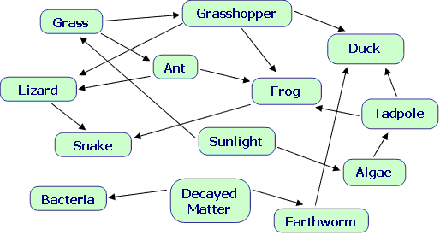

1. List all consumers in the food web.
2. If the frog was removed, who would be most affected? ________
3. What change in the food web would result in an increase in the lizard population?
4. Removing what 2 organisms would destroy the food web?