Living Things Study Guide

sunlight oxygen amphibians reptile fossils food

…………………………….

1. What type of animal goes through a metamorphosis? ___amphibian_________.
2. What animal will be more active in the day because their body temperature changes with the temperature? reptile_______
3. Tall trees get more ___sunlight____ than shorter trees.
4. We can learn how the environment has changed by studying _____fossils___.
5. Fish use gills and birds use lungs to breath? ____oxygen____
6. Green plants make their own ___food___ and give off _____oxygen_____.
7. When habitats are destroyed, what will most animals do?

They will move to a new area to live.

1. What do fish need to live?

water oxygen food

1. Draw the parts of a plant. Label what each part does.

Seeds- new plant flower -protects seeds, attracts bugs leaves - make food roots- absorb water, hold the plant up stem allows water and nutrients to travel up and down the plant.

1. List things that all animals need to survive.

food, shelter, water, sun , air

Use the food web to answer the following questions.

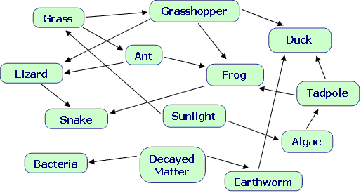

1. List all consumers in the food web.

grasshopper duck tadpole frog ant lizard snake bacteria earthworm

1. If the frog was removed, who would be most affected? _snake_____
2. What change in the food web would result in an increase in the lizard population? More snakes
3. Removing what 2 organisms would destroy the food web?

grass and algae