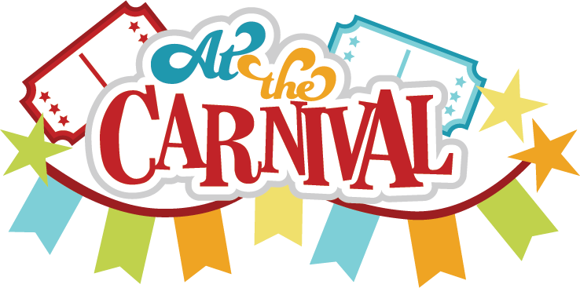

Haigh Families,

Next Wednesday, April 26th, we will be hosting our second annual HAIGH CARNIVAL for our April PBIS celebration. Students who have maintained positive behavior will have the opportunity to attend the carnival and play some awesome games and even win some prizes!

However, the event can only be a success with your help and donations. Below is a list of items that we are in need of for our celebration. If you are able to contribute or donate in any way, it would be GREATLY appreciated. You can turn in all donations to your child’s teacher.

**We are asking that donations be turned in by Monday, April 24th.**

* **Empty cardboard boxes (all sizes and shapes needed)**
* **Hershey’s Kisses**
* **Washable tattoos**
* **DumDum suckers**
* **Fake frogs (rubber/silicone)**
* **Solo cups**
* **Cotton Candy buckets (Wal-Mart?)**

This is a whole school event, so we will need as many donations as possible (we have almost 500 students!).

We are also in need of volunteers to help run stations at the carnival. If you are able to volunteer your time, it would also be appreciated. The time slots are as follows:

**A.M. session - 8:50-11:30 P.M. session - 1:30-3:15**

We need **7 A.M. volunteers and 7 P.M. volunteers.** If you are able to volunteer, please e-mail Ms. Otto at [ottoc@dearbornschools.org](mailto:ottoc@dearbornschools.org)to sign-up :)

Thank you for all of your help and continued support!

The PBIS team

