|  |
| --- |
| **Directions**  **1.Read the article closely and critically**  **2.ANNOTATE it by using sentence starters from meta-cognitive sentence starters ( use different strategies) on page2**  **3.Look up the meanings of words in bold print**  **4. Identify P.P.A.T.T (Purpose, point of view, Author, Techniques, and Tone)** |

National Geographic

Syrian Refugees October 2015

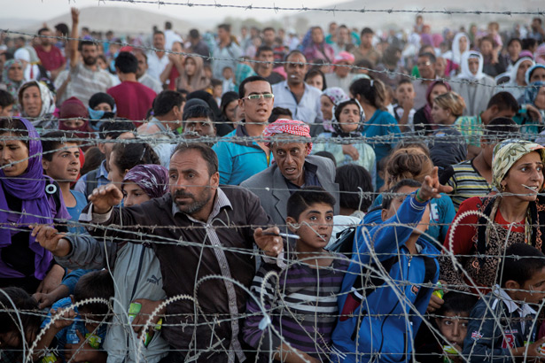

### Millions of Syrians escape an apocalyptic civil war, creating a historic crisis.

**By Paul Salopek**

**What happens when you become a war refugee? You walk.**

True, in order to save your life—for example, as militants assault your village—you might first speed away by whatever conveyance possible. In the family car. Or in your neighbor’s fruit truck. Aboard a stolen bus. Inside a cart pulled behind a tractor. But eventually: a border. And it is here that you must walk. Why? Because men in uniforms will demand to see your papers. What, no papers? (Did you leave them behind? Did you grab your child’s hand instead, in that last frantic moment of flight? Or perhaps you packed a bag with food, with money?) It doesn’t matter. Get out of your vehicle. Stand over there. Wait. Now, papers or no papers, your life as a refugee genuinely starts: on foot, in the attitude of powerlessness.

**In late September** near the border crossing in Turkey, Syrian refugees came pouring across the fallow pepper fields by the tens of thousands. They were ethnic Kurds. They were running from the bullets and knives of the Islamic State. Many came in cars, , in delivery vans and pickup trucks, raising clouds of fine, white dust from some of the oldest continuously farmed fields in the world. The Turks would not allow such a motley caravan to pass. A parking lot of abandoned cars grew at the boundary. So it begins. You take a step. You exit one life and enter another. **You walk through a cut border fence into statelessness, vulnerability, dependency, and invisibility. You become a refugee.**

**“They burned the city twice,”** Atilla Engin said, a barren man-made hill in southeastern Turkey. “We don’t know who or why. There were many wars back then.”

Engin is a Turkish archaeologist from the University of Cumhuriyet. He stared into a square pit being dug into the mound’s summit by villagers working under the direction of his graduate students. The hole was 30 feet deep, and the mound was among the biggest in Turkey: 120 feet high and 500 yards long, a lopsided layer cake of time. Its oldest evidence of occupation dated from the Neolithic, some 9,000 years ago. But above that—built, abandoned, and long since forgotten—lies the debris of at least nine human eras.

“Things don’t change,” Engin said. He had the tired half smile of a man who thought in millennia. “Outside powers still fight over this area—the Mesopotamian plain. It is the meeting place of Africa, Asia, and Europe. It is the center of the Middle East. It is a gateway of the world.”

From a ladder that he used to photograph his sprawling dig, Engin could almost see the refugee camp near Kilis, a nearby Turkish town on the Syrian border. Some 14,000 people who had fled Syria’s apocalyptic civil war have been stewing for two and a half years in the camp, stupefied by boredom. An additional 90,000 Syrians have thronged the ramshackle town, doubling its original population and driving up the rents. (The previous week an anti-Syrian mob had attacked refugees and smashed their cars.)

There are about 1.6 million Syrian war refugees in Turkey. Another eight million or more are internally displaced within Syria or eke out a hand-to-mouth living in such fragile way stations as Lebanon and Jordan. The war has bled into neighboring Iraq too, of course, where the zealots of the Islamic State have uprooted another two million civilians. All told, perhaps 12 million souls are adrift across the larger Middle East.

“This isn’t just about Turkey or Syria anymore,” Selin Ünal, a spokeswoman for UNHCR, the UN refugee agency, told me in the Kilis camp. “This is a problem that will affect the entire world. There is something historic going on here.”

**The United Nations calculates** that by the end of 2013, more than 51 million people worldwide were displaced because of warfare, violence, and persecution. More than half were women and children. Among Syrian refugees in Turkey, the proportion of women and children zooms to 75 percent. The men stay behind to fight or protect property. The women and children become wanderers. Journalists rarely follow these women’s fates into urban slums, crowded camps, plastic lean-tos pegged in watermelon fields. Into brothels. There are few dramatic explosions. Syria’s women suffer their wars alone, in silence, in alien lands.

“Nobody protects you,” said Mona (not her real name), a young Syrian woman stranded in the Turkish city of Şanlıurfa. “You get harassed constantly. Three men tried to pull me into a car. They grabbed my arm. I screamed. The people on the sidewalks did nothing. They did nothing. I want to leave this place. Can you help me? Where can I go?”

In the charred ruins of his ancient city under the Oylum mound, Engin has discovered two bodies. Both these victims of the city’s mysterious destruction were female. We know next to nothing about them except perhaps the pathos of their social status. Their skeletons lay curled inside the kitchen of a grand mud-brick palace.

After a false Arab Spring, a hard winter was coming to the Middle East.

|  |
| --- |
| **Visualizing: Questioning Making connections Identifying a problem**  I can see…. I wonder about…. This reminds me of I got confused when…  Could this mean… I’m not sure of… |