**Syrian Refugees Move Back to Camps in Jordan**

Increasingly strained resources are driving some refugees out of urban areas back to camps.

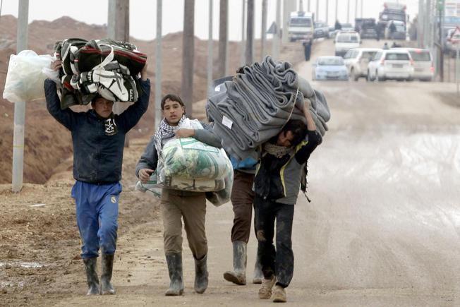[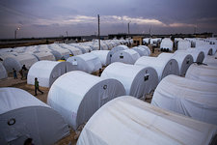](http://www.usnews.com/photos/refugee-crisis-escalating-in-syria)

Syrian refugees carry blankets at the Zaatari refugee camp, northeast of the Jordanian capital Amman, on Jan. 11.

By [Teresa Welsh](http://www.usnews.com/topics/author/teresa-welsh)Jan. 28, 2015

U.S. news and World Report

Syrian refugees in Jordan are migrating to refugee camps, in a trend aid workers say is new for a largely urban population that's placed a strain on Jordanian resources. The country has been one of the most generous in providing refuge for Syrians but has appeared to change its approach of late, which could in turn [further stress already-taxed aid groups](http://www.usnews.com/news/articles/2015/01/09/syrian-refugee-crisis-challenges-international-aid-organizations).

[**OPINION:**[Lebanon, Jordan and Turkey Need Aid To Deal with Syrian Refugee Crisis](http://www.usnews.com/opinion/blogs/world-report/2015/01/16/lebanon-jordan-and-turkey-need-aid-to-deal-with-syrian-refugee-crisis)]

"The government of Jordan is making these decisions based on the fact that they’re just overwhelmed," says Jana Mason of the U.N. refugee agency, referring to Jordan's recent decision to[cut off free health care for Syrian refugees](http://www.telegraph.co.uk/news/worldnews/middleeast/syria/11261468/Jordan-repeals-free-medical-aid-for-Syrian-refugees.html). "Obviously it’s an unfortunate decision, but it’s hard not to see the strain that’s on Jordan for its own budget and meeting the needs of its own population."

The Syrian civil war began displacing people in 2011and refugees now are severely straining infrastructure in neighboring nations. A recent report by the Office of the United Nations High Commissioner for Refugees – the U.N. refugee agency – found that [there are more than 618,500 Syrian refugees](http://unhcr.org/jordan2014urbanreport/home-visit-report.pdf#_ga=1.55358187.1596526622.1419012581) registered with the organization in Jordan, which represents nearly a tenth of the country’s total population of nearly 6.5 million. The total number of Syrian refugees in Jordan is estimated to be 1.3 million.

Eighty-four percent of Syrian refugees in Jordan have been living outside official refugee camps, but accessing basic services like housing, food, health care and education can be challenging for a population spread out in urban areas. Mason, a senior adviser for government relations and external affairs for the U.N. refugee agency, recently returned from a trip to Jordan and says her organization noticed the new pattern.

**[Refugee Crisis Escalating in Syria](http://www.usnews.com/photos/refugee-crisis-escalating-in-syria)**

“Some of what we call the urban, non-camp population is actually choosing to move back into the camps or into the camps for the first time, if they’ve never been there,” Mason says. “That’s partly because even though many people might think, ‘Oh, if they’re in an urban environment renting an apartment, they’re a lot better,’ … sometimes they’re in an even more desperate situation than those people in camps, particularly as time goes on and their resources run out.”

According to the refugee agency, the population of the Zaatari refugee camp in Jordan has increased to 85,000 from 79,000 due to urban migrants. That camp is desirable because it has supermarkets and electricity, but is at or nearly at capacity. Those now returning to camps are being sent to Azraq, which lacks those amenities, unless they have family at Zaatri. Exact counts of refugees in the camps are difficult to keep track of, because people are constantly coming and going.

Mason says because the refugee crisis has been going on so long, even those who fled Syria with savings have run out of funds. The majority of the urban refugee population rents their housing, often living in accommodations Mason calls “substandard.” Some live in apartments, but others live in repurposed school buildings, sports facilities and warehouses.

Many refugees also have moved in with family and friends in Jordan, but their generous hosts have strained resources as well.

Matters are complicated by the fact that Syrian refugees are not allowed to legally work in Jordan, making it difficult for those who’ve run out of money to earn an income. Some are able to find informal jobs, but they can be sent back to camps if caught by the Jordanian government.

Jordan's decision to end free health care for the refugees comes after the government reportedly [spent an estimated 19 million euros](http://www.thetimes.co.uk/tto/news/world/americas/article4280695.ece) ($21.5 million) to provide services for Syrians. According to the U.N. refugee agency, 77 percent of Syrian refugees in Jordan utilized public health services in 2014, while 16 percent of the population used health care services provided by nongovernmental organizations.

[**ALSO:**[Syrian Refugee Crisis Challenges International Aid Organizations](http://www.usnews.com/news/articles/2015/01/09/syrian-refugee-crisis-challenges-international-aid-organizations)]

“By cutting off medical assistance, that’s one way to push some refugees to potentially go back to camps and out of urban areas,” says Eleanor Acer, director of the refugee protection program at advocacy organization Human Rights First. “There’s some concern that some of the cuts by the Jordanian government may be partly aimed at pushing people back into camps.”

Acer, who also recently visited Jordan, says camps are more equipped to provide people with adequate health care services that are no longer affordable in urban areas. It's also easier to track and meet other needs of the refugee population when they are concentrated in one area.

Jordan additionally has taken action to stem the flow of new refugees by turning away some Syrians at the border, making it difficult for those fleeing violence to reach safety. Refugees can be denied admittance if they don’t have proper travel documents, which Acer says is a way for the Jordanian government to verify that those entering don’t pose a terrorist threat. Yet many who are fleeing violence, she says, don’t have time to grab their passports or never had one in the first place.

Syrian refugees have also fled to Lebanon, Turkey and Iraq, while others are displaced but remain within Syria itself. Jordan [reportedly has deported some refugees](http://www.hrw.org/news/2014/11/23/jordan-vulnerable-refugees-forcibly-returned-syria) back to Syria, which human rights advocates say violates [a principle of international law](http://www.unhcr.org/419c75ce4.html) barring states from returning refugees to a place where their lives may be in danger for reasons including race, religion or political opinion.

Mason emphasizes that not all Syrians are moving back to camps, but that the trend may continue if refugees become too desperate.

“People prefer the freedom, and just more dignity, of living in the urban areas,” Mason says. “Ultimately, we’d like to move away from camps and have everyone in a non-camp situation, but it has challenges.” 