**Elements of a Short Story**

A short story is a short work of fiction. Fiction is prose writing about

imagined events and characters.

http://users.aber.ac.uk/jpm/ellsa/character.gif

A character is a person, or sometimes even an animal, who takes part in the action of a short story or other literary work.

http://users.aber.ac.uk/jpm/ellsa/setting.gif

The setting of a short story is the time and place in which it happens. Authors often use descriptions of landscape, scenery, buildings, seasons or weather to provide a strong sense of setting.

http://users.aber.ac.uk/jpm/ellsa/plot.gif

A plot is a series of events and character actions that relate to the central conflict.

http://users.aber.ac.uk/jpm/ellsa/conflict.gif

The conflict is a struggle between two people or things in a short story. The main character is usually on one side of the central conflict.

On the other side, the main character may struggle against another important character, against the forces of nature, against society, or even against something inside himself or herself (feelings, emotions, illness).

http://users.aber.ac.uk/jpm/ellsa/theme.gif

The theme is the central idea or belief in a short story.

Plot Structure Components

1. 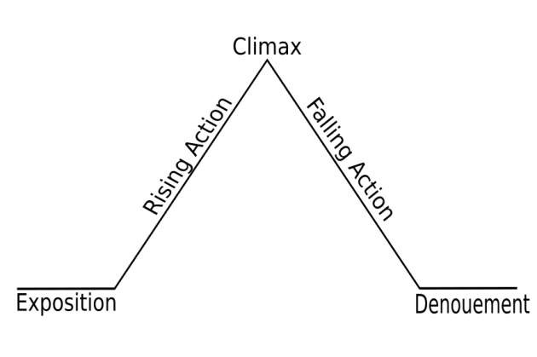**Exposition** — The opening of the story, including a reader’s introduction to characters and settings.
2. **Rising Action** — the series of conflicts and crisis in the story that lead to the climax.
3. **Climax** — **The turning point**. The most intense moment (either mentally or in action).
4. **Falling Action** — A series of events that unfold after the climax and lead to the end of the story.
5. **Resolution** — The end of the story, in which the problems are resolved (or not resolved, depending on the story.) Also called the denouement, catastrophe, or revelation.