1. Find the value of *x* in rhombus ABDC. Then find each side length.

    

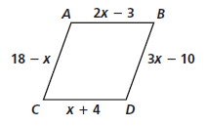

**Find the measure of the numbered angles for each parallelogram.**

2.  3. 

 

 

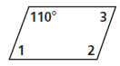 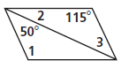

**Find the value of x in each parallelogram below.**

4. 5. AC = 24.

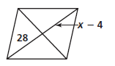 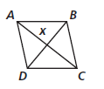 

**Find the values for which the figure is a parallelogram.**

6.   7.  

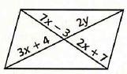 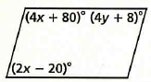

Turn to the back for more ☺

