H. Geometry - Bellwork #8 Date: __________

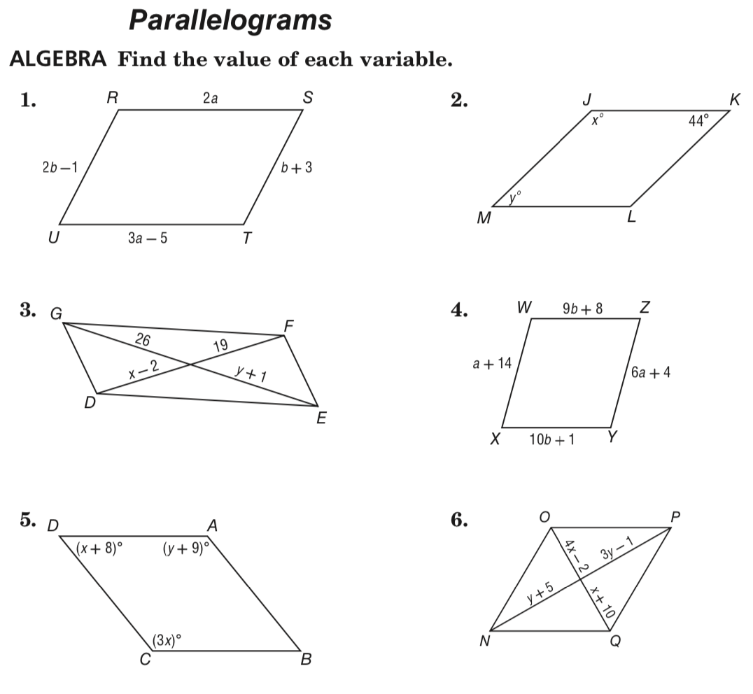

Turn to the back for more
