**H. Geometry - Bellwork #12 Date: __________**

**Theorems to Prove Quadrilaterals are Parallelograms:**

* If both pairs of opposite sides of a quadrilateral are congruent, then the quadrilateral is a parallelogram.
* If both pairs of opposite angles of a quadrilateral are congruent, then the quadrilateral is a parallelogram.
* If an angle of a quadrilateral is supplementary to both consecutive angles, then the quadrilateral is a parallelogram.
* If the diagonals of a quadrilateral bisect each other, then the quadrilateral is a parallelogram.
* If one pair of opposite sides of a quadrilateral are both congruent and parallel, then the quadrilateral is a parallelogram.

**Is there enough information to prove the quadrilateral is a parallelogram? If so, write a theorem as justification why it is a parallelogram.**

A

D

C

B

E

1) and 2) and 3) and

4) ∠ADC ≅ ∠CBA and 5) ∠DAB is supplementary to ∠ADC 6) ΔAED ≅ ΔCEB

∠BAD ≅ ∠DCB ∠ABC is supplementary to ∠BCD

Turn to the back for more ☺

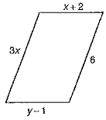**Determine the value of x and y so that the quadrilateral is a parallelogram.**

A

D

C

B

E

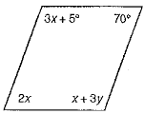1) 2) 3)

AE = x2 – 45, EC = -3x - 5

DE = 2y2, EB = -3y + 2