**H. Geometry 6-6: Conditions of Special Parallelograms Date: ____________**

**Objective: I can identify rhombuses, rectangles, and squares by the characteristics of their diagonals.**

**Do “Model and Discuss” and Habits of Mind in your student companion, page 157.**

Answer this question after you do page 157.

1) Which triangles in the diagram appear to be congruent?

Fill in the essential question for this section: What properties of the _____________________

of a __________________________ help you to classify a _____________________________?

**Example 1:** What can you conclude about the figure below based on the given information?

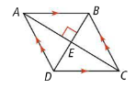

*What information is given that is NOT true of all parallelograms?

**Do Try It 1, page 158 in your student companion.**

**Theorem 6-19 (converse of theorem 6-16)**

If

then the parallelogram is a rhombus.

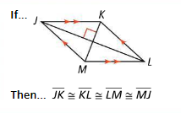

**Theorem 6-20 (converse of theorem 6-17)**

If

then the parallelogram is a rhombus.

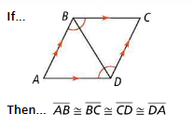

**Example 2:** Complete the proof of Theorem 6-20.

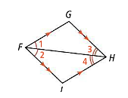Given: Parallelogram FGHJ with $∠1≅∠2$ and $∠3≅∠4$.

Prove: FGHJ is a rhombus.

*How could you describe $∆FGH and ∆FJH?$

**Do Try It 2 and Habits of Mind, page 158 in your student companion.**

**Example 3:** Ashton measures the diagonals for his deck frame and finds that they are congruent. Will the deck be rectangular? Explain.

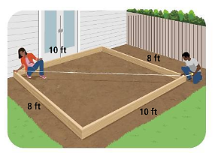

**Do Try It 3, page 158 in your student companion.**

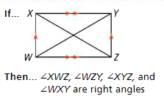

**Theorem 6-21 (converse of theorem 6-18)**

If

then the parallelogram is a rectangle.

**Example 4:** Can you conclude whether each parallelogram is a rhombus, square, or a rectangle? Explain.

A) Parallelogram ABCD

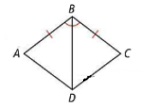

B) Parallelogram PQRS

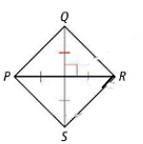

**Do Try It 4, page 159 in your student companion.**

*What properties do you need to know about parallelograms to do A and B in Try It 4?

**Example 5:** Quadrilateral STUV is a rhombus. What are the values of *x* and *y*?

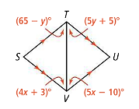

*What is true about all 4 marked angles in STUV?

**Do Try It 5, page 159 in your student companion.**

*Would making a sketch help solve this problem?

**Example 6: A** group of friends set up a kickball field with bases 60 feet apart. How can they verify that the field is a square?

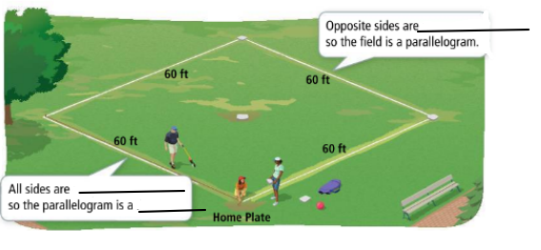

**Do Try It 6 and Habits of Mind, page 159 in your student companion.**

*How can you show that MNPQ is a parallelogram?

**In the book:**

Read Concept Summary and #1-10, page 291 (page 160 in your student companion).

Tomorrow’s HW: page 292 #12, 16-24, 26, 28, 29

**Use this Venn Diagram for #4**