H. Geometry 6-5: Properties of Special Parallelograms Date: ____________

**Objective: I can use the properties of rhombuses, rectangles, and squares to solve problems.**

**Do “Explore and Reason” and Habits of Mind in your student companion, page 153.**

Answer these questions after you do page 153.

1) What characteristics of the figures did you ask about to try to classify them?

2) Do you think that squares, rectangles, and rhombuses have properties beyond the properties that are part of their definition?

Fill in the essential question for this section: What properties of _____________________, ____________________, and ________________ differentiate them from other

__________________________?

**Example 1:** Find the diagonals of a rhombus.

A) Parallelogram ABCD is a rhombus. What are the measures of $∠1, ∠2, ∠3,$ and $∠4$?

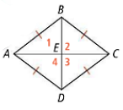

B) Parallelogram JKLM is a rhombus. How are $∠1, ∠2, ∠3,$ and $∠4$ related?

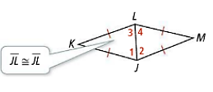

*What types of triangles are $∆JKL and ∆JML?$

*What does this suggest about the 4 angles?

**Do Try It 1, page 154 in your student companion.**

**Let’s look at some special properties of rhombuses.**

**Theorem 6-16:**

If a parallelogram is a rhombus, then

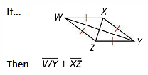

**Theorem 6-17:**

If a parallelogram is a rhombus, then

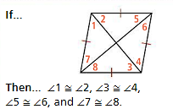

**Example 2:** Find lengths and angle measures in a rhombus.

A) Quadrilateral ANCD is a rhombus. What is $m∠ADE?$

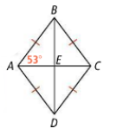

B) Quadrilateral GHJK is a rhombus. What is *GH*?

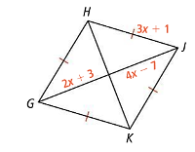

**Do Try It 2 and Habits of Mind, page 154 in your student companion.**

**Let’s look at special properties of rectangles.**

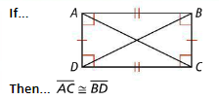

**Theorem 6-18:**

If a parallelogram is a rectangle, then

**Example 3:** Prove diagonals of a rectangle are congruent.

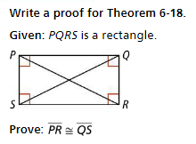

|  |  |
| --- | --- |
| **Statements** | **Reasons** |
| 1. PQRS is a rectangle. | 1. |
| 2.PQRS is a parallelogram. | 2. |
| 3. $\overline{PS}≅\overline{QR}$ | 3. |
| 4. $∠PSR$ and $∠QRS$ are right angles. | 4. |
| 5. $∠PSR≅∠QRS$ | 5. |
| 6. $\overline{SR}≅\overline{RS}$ | 6. |
| 7. $∆PSR≈∆QRS$ | 7. |
| 8. $\overline{PR}≅\overline{QS}$ | 8. |

**Do Try It 3, page 155 in your student companion.**

**Example 4:** Paul is training his horse to run the course at a pace of 4 meters per second or faster. Paul rides his horse from D to C to E to B in 1 minute and 30 seconds. The figure ABCD is a rectangle. Did he make his goal?

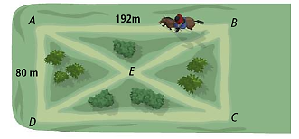*Why is it useful to know the length of BD?

**Do Try It 4, page 155 in your student companion.**

**Example 5:** Figure WXYZ is a square. IF WY + XZ = 92, what is the area of $∆WPZ?$

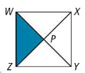

When you see a problem involving a square, what properties should you consider?

Why can you use WP and ZP as the base and height of $∆WPZ?$

**Do Try It 5 and Habits of Mind, page 155 in your student companion.**

**In the book:**

Read Concept Summary and #1-12, page 283 (page 156 in your student companion.)

Tomorrow’s HW: page 284 #14, 15, 17-20, 22, 24-28, 32, 35, 36