**H. Geometry 6-4: Proving a Quadrilateral is a Parallelogram Date: ____________**

**Objective: I can use the properties of parallel lines, diagonals, and triangles to investigate parallelograms.**

**Do “Explore and Reason” below.**

Sketch and name each quadrilateral. Mark any congruent sides and angles in your diagrams.

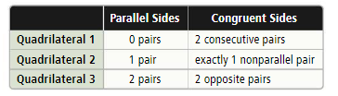

|  |  |  |
| --- | --- | --- |
| Quadrilateral 1 | Quadrilateral 2 | Quadrilateral2 |
|  |  |  |
| This is a(n) | This is a(n) | This is a(n) |

What properties of a quadrilateral do you think will prove a quadrilateral is a parallelogram?

Fill in the essential question for this section: Which ____________________ determine

whether a _______________________ is a ________________________?

**Example 1:** In quadrilateral ABCD, $\overline{AC}$ is a diagonal, $\overline{AB}≅\overline{CD}$, and $\overline{AD}≅\overline{BC}$. Is ABCD a parallelogram? Explain.

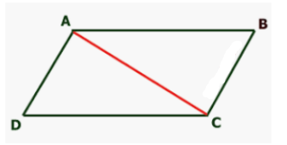

*Does it matter which diagonal is constructed?

*What conclusion can be drawn from this example?

**Do Try It 1 and Habits of Mind, page 148 in your student companion.**

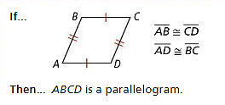

**Theorem 6-11 (converse of theorem 6-7):**

If

then, the quadrilateral is a parallelogram.

**Example 2:**

A) Teo sketches a design of a parallelogram-shaped building. If $∠1$ is supplementary to $∠2$ and $∠4$, is his design a parallelogram?

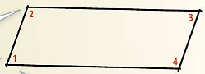



**Do Try It 2, page 148 in your student companion.**

These examples lead us to two more theorems.

**Theorem 6-12 (converse of theorem 6-8)**

If

then the quadrilateral is a parallelogram.

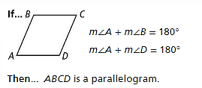

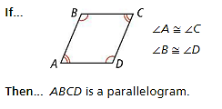

**Theorem 6-13 (converse of theorem 6-9)**

If

then, the quadrilateral is a parallelogram.

**Example 3:** Find values to make parallelogram.

A) For what values of *r* and *s* is WXYZ a parallelogram?

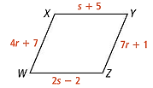

B) For what values of *a* and *b* is RSTU a parallelogram? Which angle relationship is best to use and why?

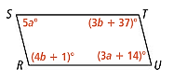

**Do Try It 3 and Habits of Mind, page 149 in your student companion.**

We have two more converses of theorems that we have previously seen to prove that a quadrilateral is a parallelogram.

**Theorem 6-14 (converse of theorem 6-10)**

If

then the parallelogram is a quadrilateral.

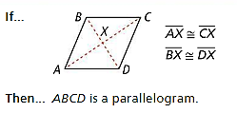

**Theorem 6-15**

If

then the parallelogram is a quadrilateral.

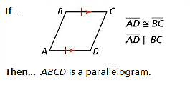

**Example 4:** Complete the proof of Theorem 6-14 below.

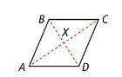

|  |  |
| --- | --- |
| **Statements** | **Reasons** |
| 1. $\overline{AX}≅\overline{CX}$ and $\overline{BX}≅\overline{DX}$ | 1. |
| 2. $∠AXD≅∠CXB$ and $∠AXB≅∠CXD$ | 2. |
| 3. $∆AXD≅∆CXB$ and $∆AXB≅∆CXD$ | 3. |
| 4. $\overline{AD}≅\overline{CB}$ and $\overline{AB}≅\overline{CD}$ | 4. |
| 5. ABCD is a parallelogram. | 5. |

**Do Try It 4, page 150 in your student companion.**

**Example 5: Are the following quadrilaterals also parallelograms? Explain.**

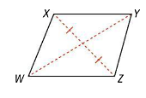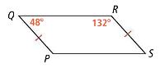A) B)

**Do Try It 5 and Habits of Mind, page 150 in your student companion.**

**Example 6:** A mechanic raises a truck using a lift. For safety, the floor must be horizontal, and the top of the lift must be parallel to the floor. Is the lift shown in a safe position? Explain.

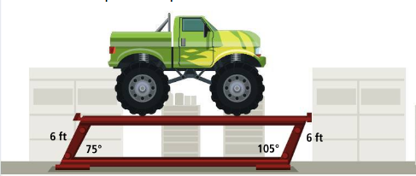

**Do Try It 6 and Habits of Mind, page 151 in your student companion.**

**In the book:** Read Concept Summary and #1-9, page 276 (page 152 in your student companion.)

Tomorrow’s HW: page 277 #10, 11, 13, 16-19, 21, 24, (3 possible points), 25, 26A, B